Tuesday 31.3.20
Please remember!
- Work can be completed in your green jotter or on a device/laptop
- You do not need to post on teams to say you have completed a job (we trust you!)
- The online chat is only to be used for questions
- Your teacher will only be available between 8.45 – 3.15 , no posts after that time. Break and lunch times still apply
- Do not put too much pressure on yourself to finish things quickly, these can be done throughout the day
- Remember you have access to apps and links such as Sumdog, Go Noodle and Activelearn. You can play these any time!
- If you finish all the tasks that we have set you can read, or decide what else to do with the rest of your day
- Try to post work in ‘assignments’ or ‘class notebook’ if you can’t do this, don’t panic. You can always upload a photo to the live chat... but you don’t have to!
Here are your jobs for today:
Writing
LI: to record information in the form of a diary
Task – Using your green jotter or device, write some diary entries for last week. How was your first week working from home? What tasks/activities did you do? How did you feel during this week? Did you feel bored having to stay inside for most of the time? Did you do any exercise or activities to take your mind off things? Remember to date each entry. Include at least 3 days' worth of entries
You can draw pictures too!

Spanish
LI: to apply knowledge of Spanish vocabulary
Task 1 – Without cheating!!
Can you remember these colours in Spanish? Get an adult to test you!
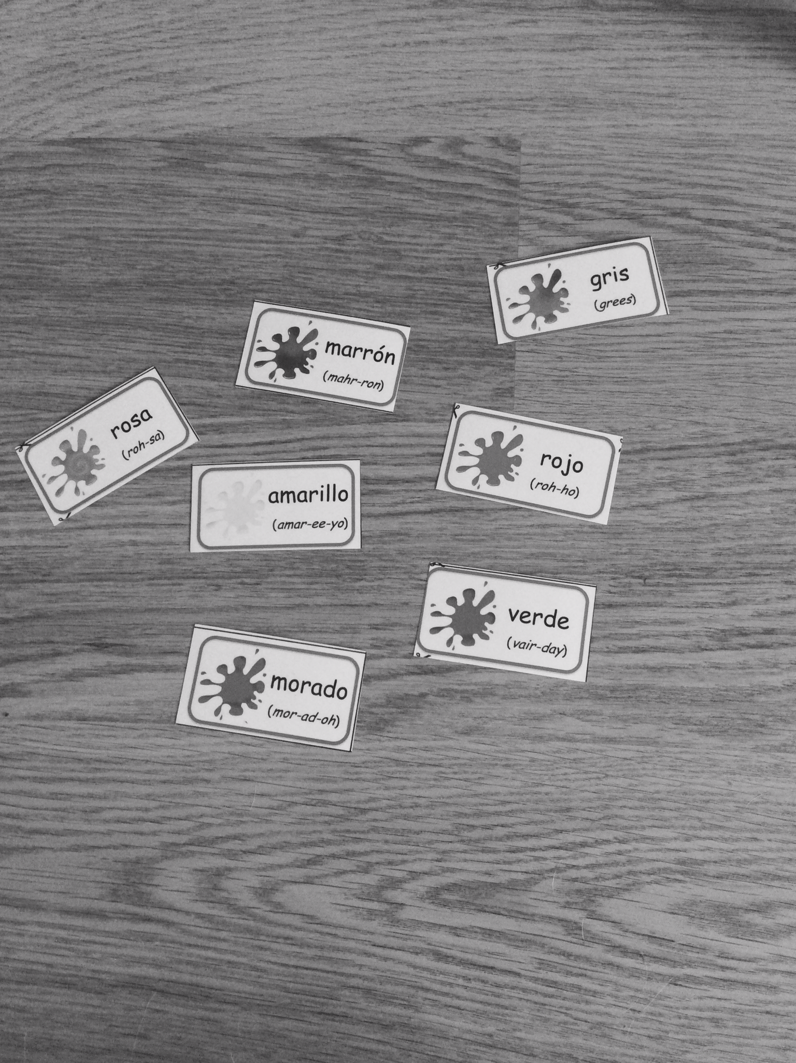
Task 2 – Look at these popular company logos, can you remember the colour of them? Try and use Spanish to say the correct colour. (If you are really stuck you can look it up.)

Numeracy
- Finish and self-mark pages given yesterday – see Monday’s Assignment
- SumDog- National Competition this week.
- Active Learn Games-Choose from the selection of games allocated to you. Clam Collector is the one that relates best to this weeks ‘Negative Number’ focus.
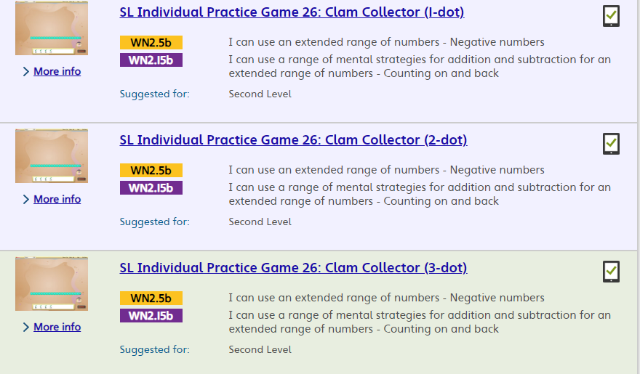

Health
L.I- To know how to keep safe online
Search https://www.thinkuknow.co.uk/8_10/watch/
- Watch Film 1 ‘Block Him Right Good Alfie!’ Play, Like, Share
- Discuss with and adult what you have learned from this clip or post on TEAMS
****We have used this clip before in class however since you may be spending more time online at the moment this is appropriate/important to revisit and revise.****

Music
Mr Muller has placed new activities in your P6P charanga inbox
This can be access here https://www.charangascotland.co.uk/yumu/login
I will give updates throughout the week about who’s access their music learning and who’s earned charanga points. If you are unable to access charanga and you don’t have a username or password, let Mr Muller know

