Monday 30.3.20
Please remember!
- Work can be completed in your green jotter or on a device/laptop
- You do not need to post on teams to say you have completed a job (we trust you!)
- The online chat is only to be used for questions
- Your teacher will only be available between 8.45 – 3.15 , no posts after that time. Break and lunch times still apply
- Do not put too much pressure on yourself to finish things quickly, these can be done throughout the day
- Remember you have access to apps and links such as Sumdog, Go Noodle and Activelearn. You can play these any time!
- If you finish all the tasks that we have set you can read, or decide what else to do with the rest of your day
- Try to post work in ‘assignments’ or ‘class notebook’ if you can’t do this, don’t panic. You can always upload a photo to the live chat... but you don’t have to!
Here are your jobs for today:
Literacy (Spelling & Reading)
Read the next chapter in your reading book or a book of your choice for around 30minutes. (If you are unsure what chapter you are on contact your teacher)
Spelling – Common words
Reds & Blues Greens
Common Words | argument, consequence, energy, improvise, outrageous | them, these, then, there, their

Spelling task – using your common words:
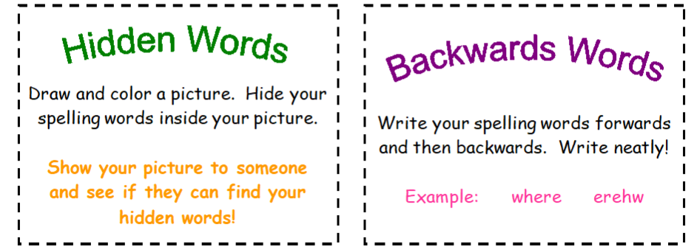
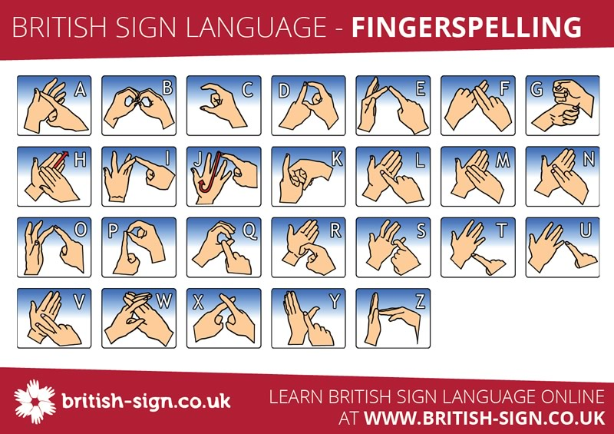

Topic
L.I- To know about the planets and our solar system
- Login to Espresso- https://www.discoveryeducation.co.uk/
- Search ‘Earth and Space’ choose Second Level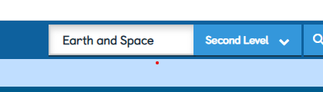
- Choose the ‘Earth and Space’ Module and then click videos. Click and watch the video ‘Our Solar System’
- Select Fact Files- The Planets and read.
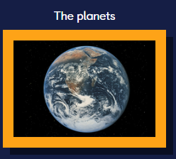

- Finally select Activities- Solar System Quiz
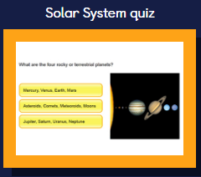

Numeracy- Negative Numbers Revision/Consolidation
All Groups would benefit from watching MathAntics Negative Numbers Video found on youtube before starting todays tasks.
https://www.youtube.com/watch?v=OAoLCXpao6s

Rectangles- TeeJay E p60
L.I- To be able to understand and use negative numbers
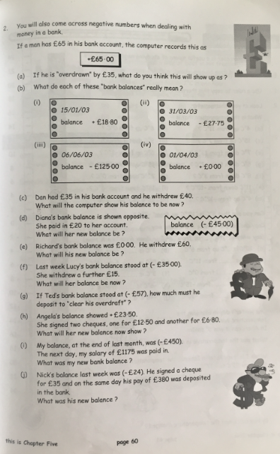

Triangles- TeeJay 2b p81
L.I-To be able to identify positive and negative numbers on a scale
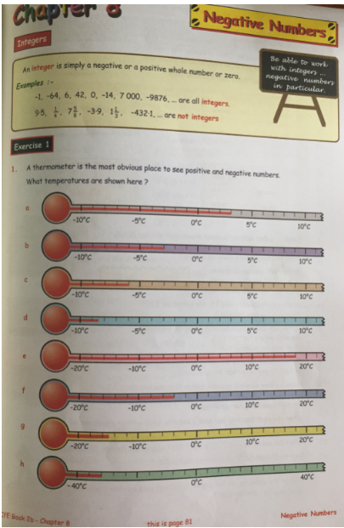

Circles
L.I- To be able to order positive and negative numbers
