Friday 27th March 2020
Please remember!
- Work can be completed in your green jotter or on a device/laptop
- You do not need to post on teams to say you have completed a job (we trust you!)
- The online chat is only to be used for questions
- Your teacher will only be available between 8.45 – 3.15 , no posts after that time. Break and lunch times still apply
- Do not put too much pressure on yourself to finish things quickly, these can be done throughout the day
- Remember you have access to apps and links such as Sumdog, Go Noodle and Activelearn. You can play these any time!
- If you finish all the tasks that we have set you can read, or decide what else to do with the rest of your day
- Try to post work in ‘assignments’ or ‘class notebook’ if you can’t do this, don’t panic. You can always upload a photo to the live chat... but you don’t have to!
Maths Problem Solving
L.I. To solve maths problems using a specific strategy
S.C. I can use logical reasoning to solve a maths probolem
Rectangles
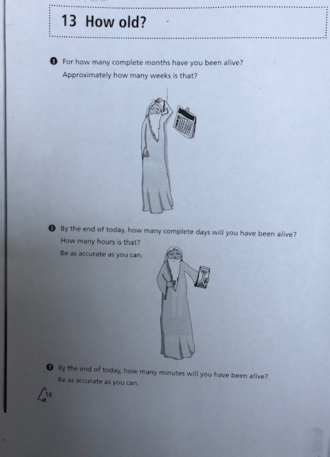

Triangles
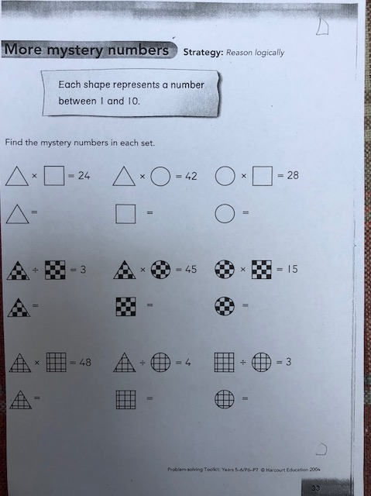

Circles
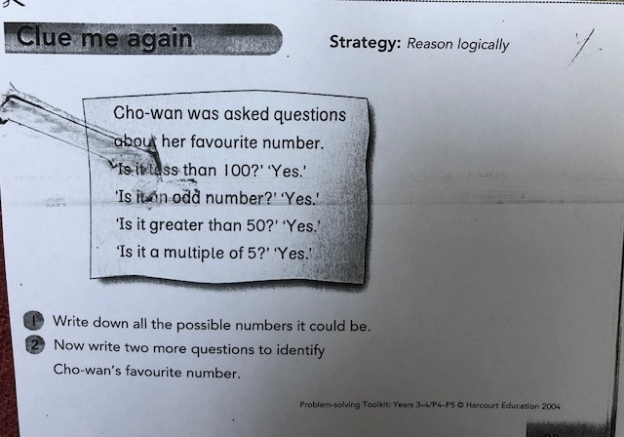

Life skills challenge
How fast can you make your bed?
Get someone to time you! Can you beat that time tomorrow?

Reward time!
You have worked very hard this week. Here are some Just Dance videos you can enjoy during reward time!

Old Town Road (Remix) by Lil Nas X Ft. Billy Ray Cyrus:
https://www.youtube.com/watch?v=_g4CYKBN9L0

High Hopes – Panic! At the Disco:
https://www.youtube.com/watch?v=dovTbPkyQO4
Rock n Roll Just Dance 2016:
https://www.youtube.com/watch?v=IDn3Kimu4DU
Pump It - The Black Eyed Peas - Just dance 3:
https://www.youtube.com/watch?v=xQ79cheWg5g

