Thursday 26th March
Primary 7 we are going to change the layout of your tasks; there will be a list of 4 core tasks to do at the top of the page and then at the bottom there will be optional extras if you would like to do them. 😊
Get Set
See how many words you can make from the letters given below and create a sentence using the words.
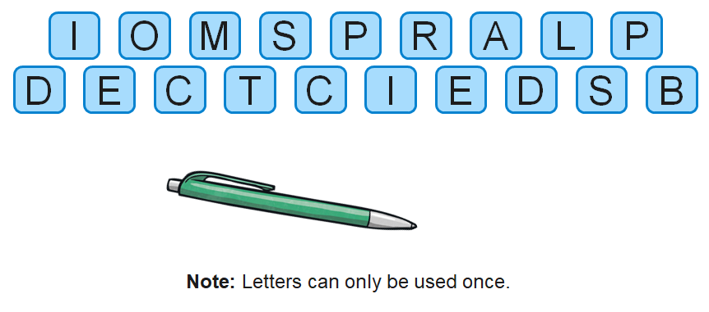
CORE TASKS FOR TODAY
1) Literacy (grammar & punctuation)
L.I. to use an apostrophe for contraction and possession
WRITTEN:
Spicy: Collins English Skills 5 pg73
Hot: Collins English Skills 6 pg31

2) NUMERACY
L.I. to practise my times tables
Take part in the SUMDOG tables assessment challenge. Good luck!

3) P.E. (from Mrs Howard)
Continue with the P.E. lessons from Mrs Howard. This can be found in the Assignments folder. Please remember to put your scores in for her to see. Can you improve your score today? Remember her JUST FOR FUN activities.

4) TOPIC
L.I. to know about the world!!
Use an atlas- book or online to help you find the answers to the following questions:
Atlas Scavenger Hunt
1. What is the capital of Japan? __________________________
2. What is the capital of Australia? __________________________
3. What is the capital of Fiji? __________________________
4. Which countries surround the Black Sea? ____________________
5. What sea is to the East of the United States? _________________
6. What is the capital of Cuba? ______________________
7. In which country is Rio de Janeiro? __________________
8. In which country is Karbala? _____________________
9. Which country does the Nile flow through? (or countries?)
10. In which countries does the Sahara lie?

Use the following image identify the following on your map:
- The different continents
- The Equator
- The tropic of Cancer and Capricorn
- The Arctic and Antarctic

Optional tasks for today
If you are looking for something else to do remember you can log in online as often and for as long as you want on the following sites:
- Studyladder https://www.studyladder.co.uk/login/account
- Espresso https://online.espresso.co.uk/espresso/login/Authn/UserPassword
- Sumdog https://www.sumdog.com/user/sign_in
- Active Learn https://www.activelearnprimary.co.uk/login?e=-1&c=0#all
- Charanga with Mr Muller https://charanga.com/site/log-in/ (There will be weekly tasks to complete for the following Monday)

9am P.E. with Joe Wicks
L.I. to improve my stamina and physical fitness
You can click on the link below and take part in a 30-minute Joe Wicks P.E. session to start your day. https://www.youtube.com/channel/UCAxW1XT0iEJo0TYlRfn6rYQ

Handwriting
L.I. to improve my cursive handwriting
In your green jotter complete one of the handwriting cards in the photographs. Choose Mild, Spicy or Hot. If you would like to do more than one then feel free to do so! 😊 Remember to use a sharp pencil and take your time.

Spelling
L.I. to practise my spelling words
Using your spelling words write them down with your eyes closed/blindfolded. Now look; can you make sense of the word? Did you spell it correctly? Try it for each word.

HWB
L.I. to keep myself safe in different surroundings
In school we have regular fire drills so that we all know what to do in an emergency. It is your turn to think of an emergency at home? If you had a home fire drill where would you go to? Create a poster either digitally or on paper to show how you can stay safe at home. What things will you need to be aware of? What safety tips can you give for others? Are there hazardous symbols or warning labels that people can find at home and what do they mean? (Top Tip: think back to the risk factory) Remember on your poster you still need the correct use of capital letters and you want it to be eye catching and well organised!
Extras
- Try to tie your shoes with one hand
- Make an envelope out of paper and write somebody a letter and put it inside it
- Dance around to your favourite song

Answers will be posted at the end of the school day where possible. You can also listen to our class novel at the end of each day using the online link https://www.youtube.com/watch?v=Lfi82CbVw1c. Well done for taking part in your Wednesday timetable online. Get ready for Thursday’s timetable tomorrow!

