Thursday 26th March 2020
Please remember!
- Work can be completed in your green jotter or on a device/laptop
- You do not need to post on teams to say you have completed a job (we trust you!)
- The online chat is only to be used for questions
- Your teacher will only be available between 8.45 – 3.15 , no posts after that time. Break and lunch times still apply
- Do not put too much pressure on yourself to finish things quickly, these can be done throughout the day
- Remember you have access to apps and links such as Sumdog, Go Noodle and Activelearn. You can play these any time!
- If you finish all the tasks that we have set you can read, or decide what else to do with the rest of your day
- Try to post work in ‘assignments’ or ‘class notebook’ if you can’t do this, don’t panic. You can always upload a photo to the live chat... but you don’t have to!

Literacy (Punctuation and Grammar) - Nouns
Reds – LI: to identify proper, collective, common and abstract nouns
Blues- LI: to understand how to use nouns formed from verbs
Greens – LI: To use proper nouns
Here are some videos to help:
Abstract and concrete nouns: https://www.youtube.com/watch?v=lF686sbSljU
Nouns: https://www.youtube.com/watch?v=GlGJ8gANeGo
Pronouns: https://www.youtube.com/watch?v=aSwTlQNLqPA
There is a page for you to do depending on your group. Make sure that you are competing the correct page 😀

Reds (Complete up to at least q12, complete all if you want!)
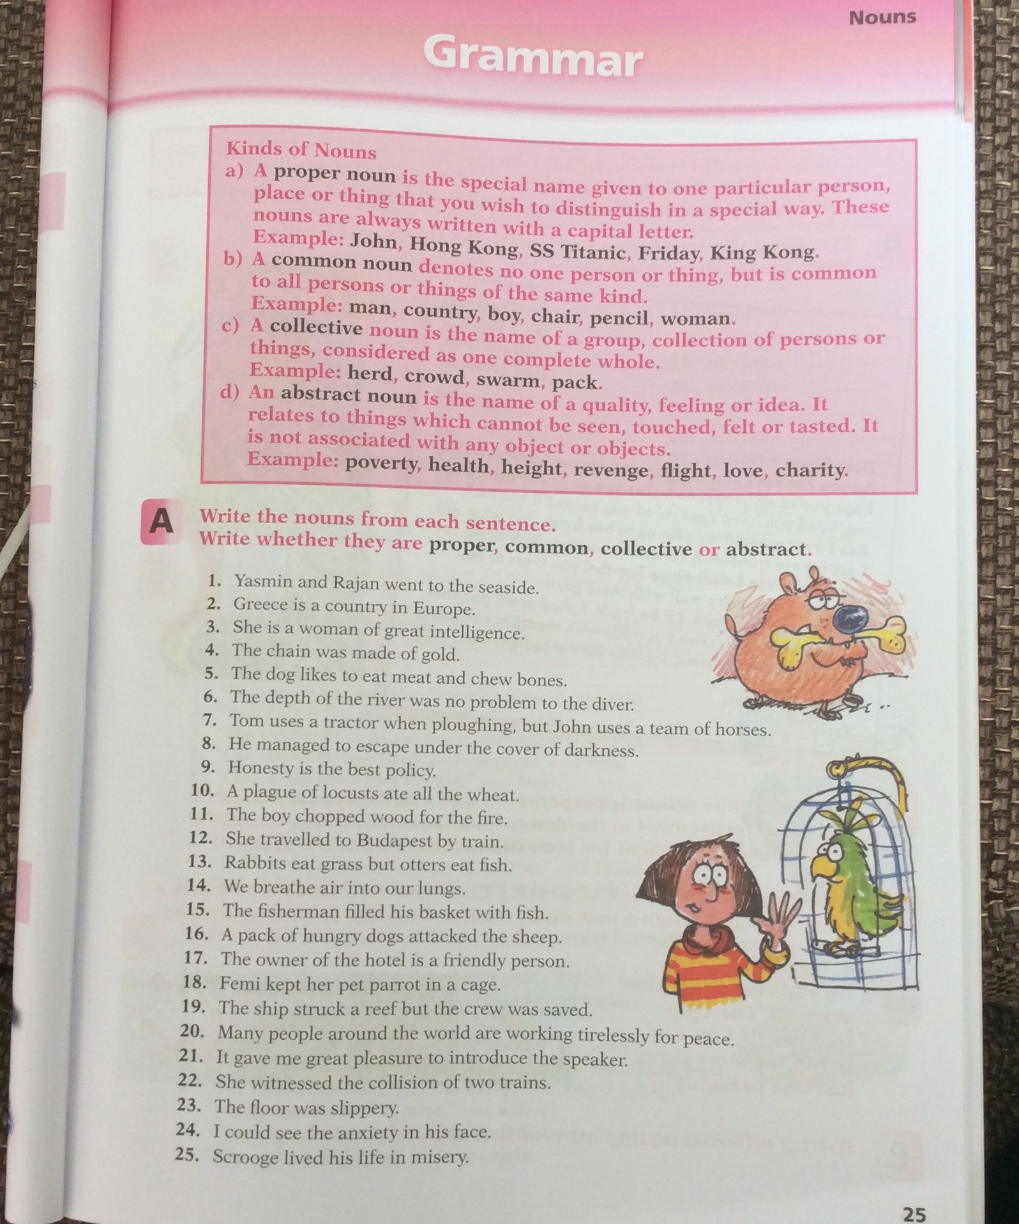

Blues (Complete Focus and Practice)
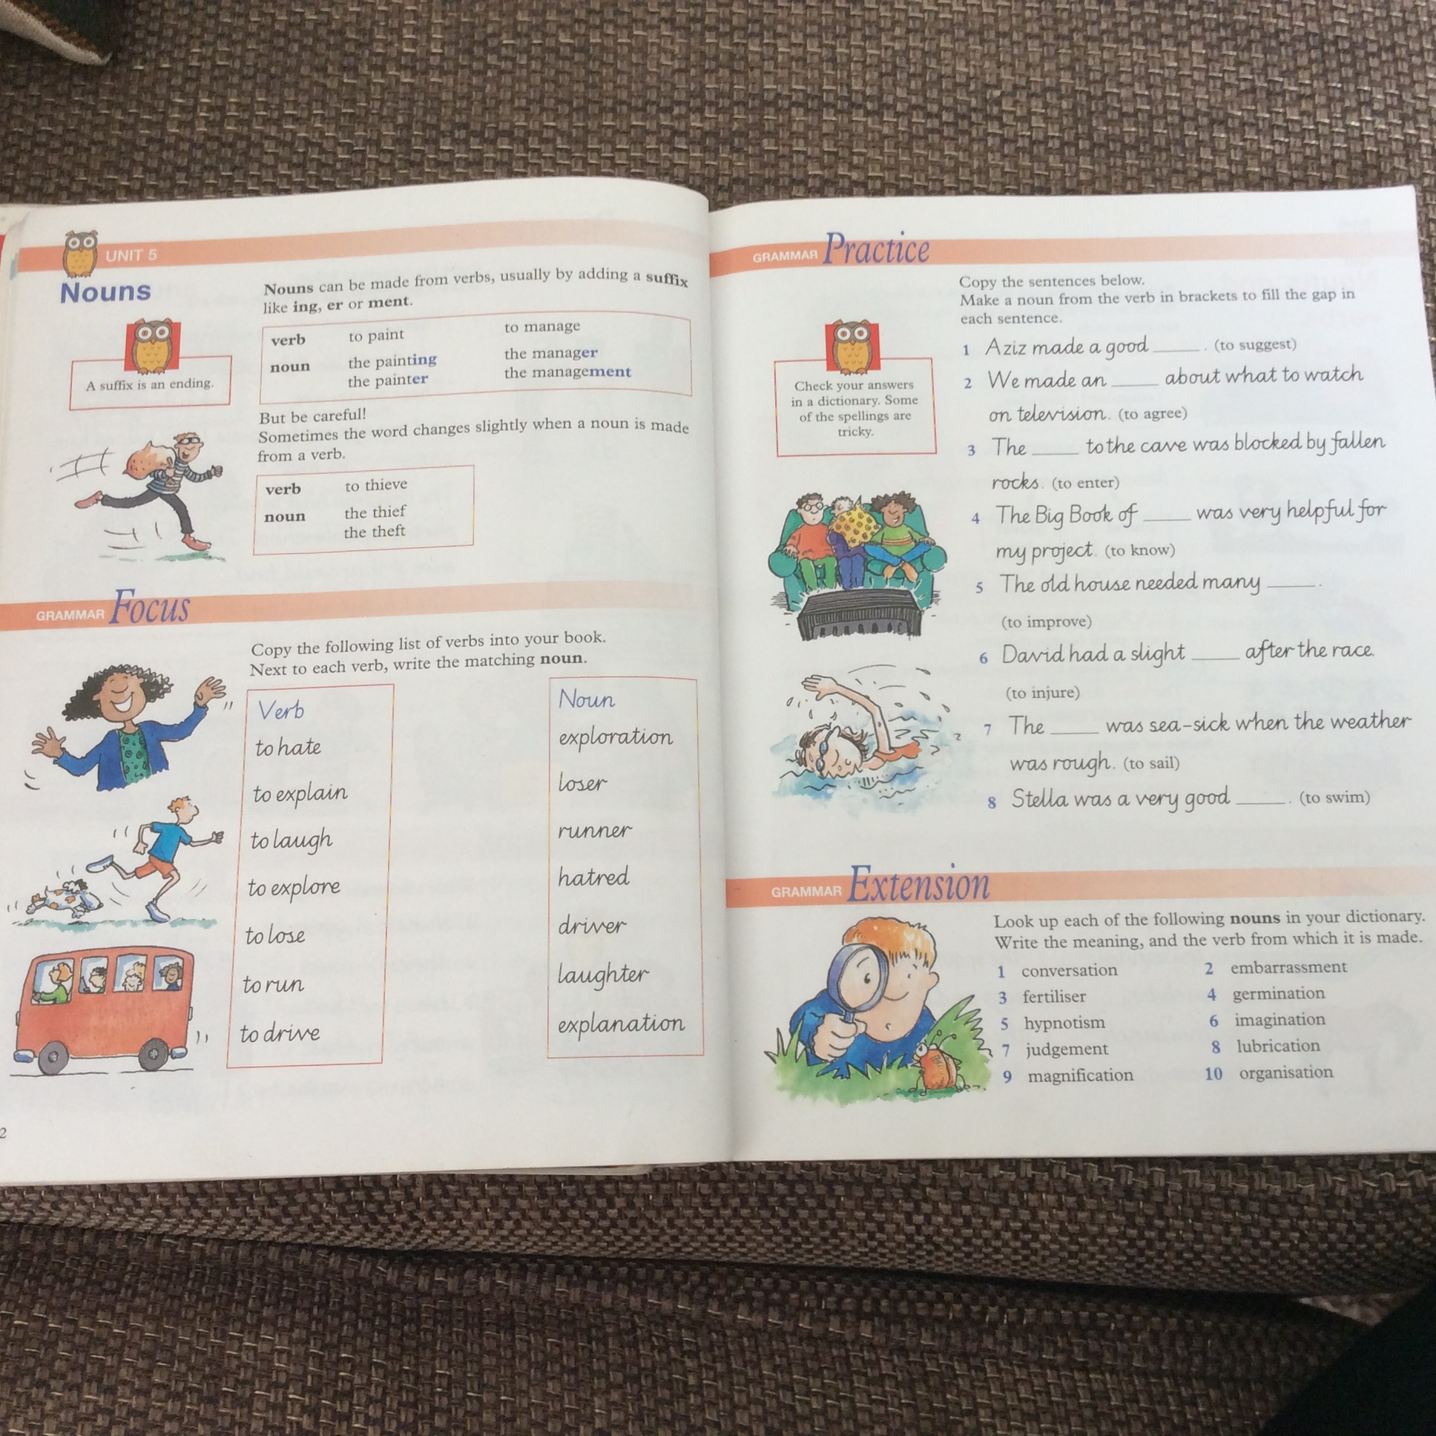

Greens (Complete Focus and Practice)
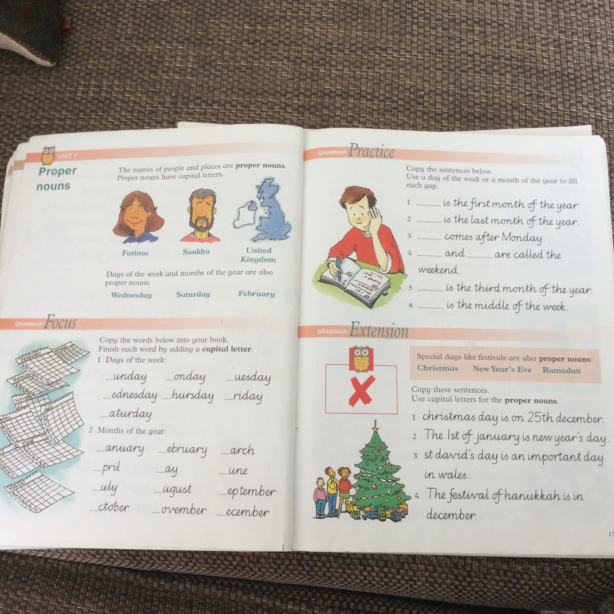

Topic
Topic Work
L.I. To create a presentation to be shared with an audience
S.C. To include 5 key pieces of information on your assigned Asian Country
S.C. To include digiskills in your presentation

This is a continuation of the project you started in class. You wont be able to present with your partner now but you can use imovie, Microsoft Powerpoint or Sway to create your presentation. You’ll be able to access these tools using the “waffle” in the top left corner when you log into glow.
Be creative!

Maths – Area
MATHS LI – to calculate the surface area of a square or rectangular household item. (26.3.20)
Starter – watch https://www.youtube.com/watch?v=xCdxURXMdFY (from 0:00 to 4:30)
Check out - https://www.activelearnprimary.co.uk/login?c=0 and https://www.studyladder.co.uk/where there are games to help you understand area!
Measuring the length and width of everyday household items using a ruler or measuring tape, such as table tops, work surfaces and windows, work out the surface area of these using the techniques from last week (length times by width)
Remember to multiple (X) the length in cm by the width in cm to get your answer. Also remember your answer should read cm2 at the end.
For example, Mr Muller has measured his favourite book and it measures 22cm length and 16cm width. He would then complete the sum 22cm x 16cm = 352cm2
HOT – safely find 7 examples in your home or garden
SPICY – safely find 5 examples in your home or garden
MILD – safely find 3 examples in your home or garden
(These should be recorded in your green jotters)

MUSIC
Remember to log into https://www.charangascotland.co.uk/user/login

There are some fun music modules to complete. If you don’t have your login username or password, let Mr Muller know and I will have them emailed out to you.

