26.3.20. Literacy
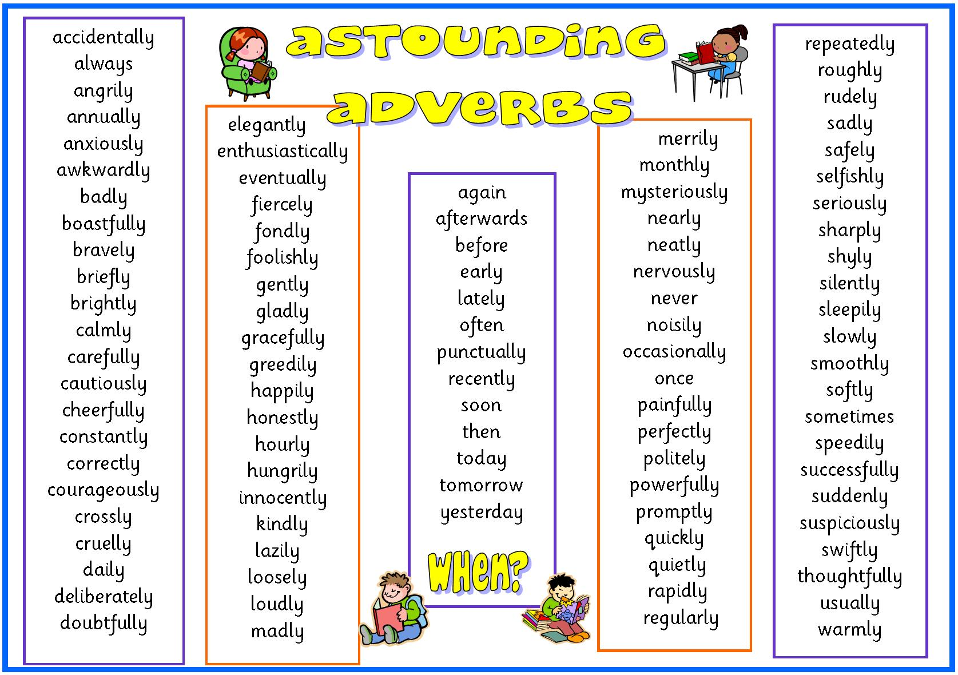
L.I. To identify and use adverbs
Watch the video https://www.youtube.com/watch?v=94aFcx6oliY
Alliteration – Please complete sections A and B
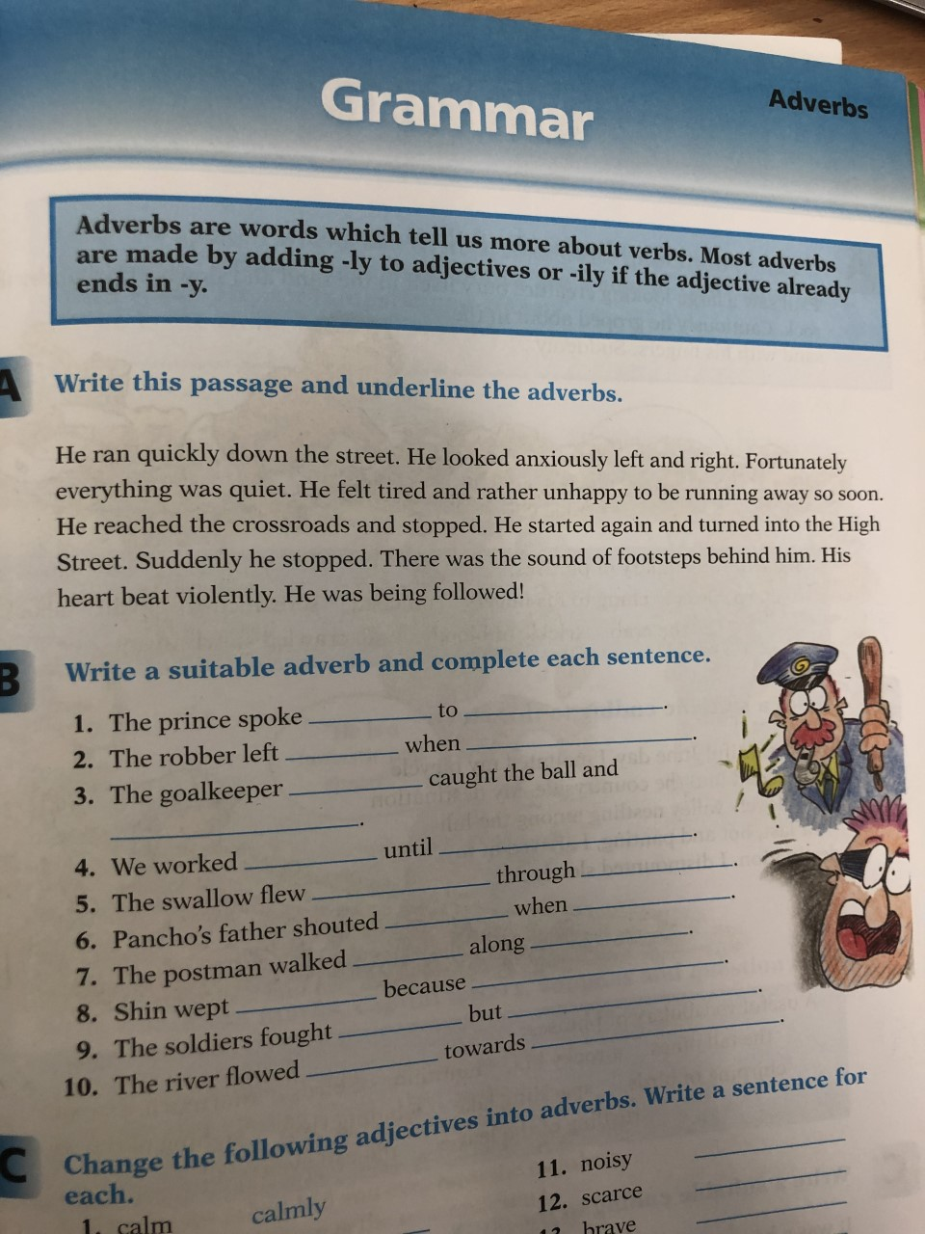

Metaphor - Please complete sections A and B
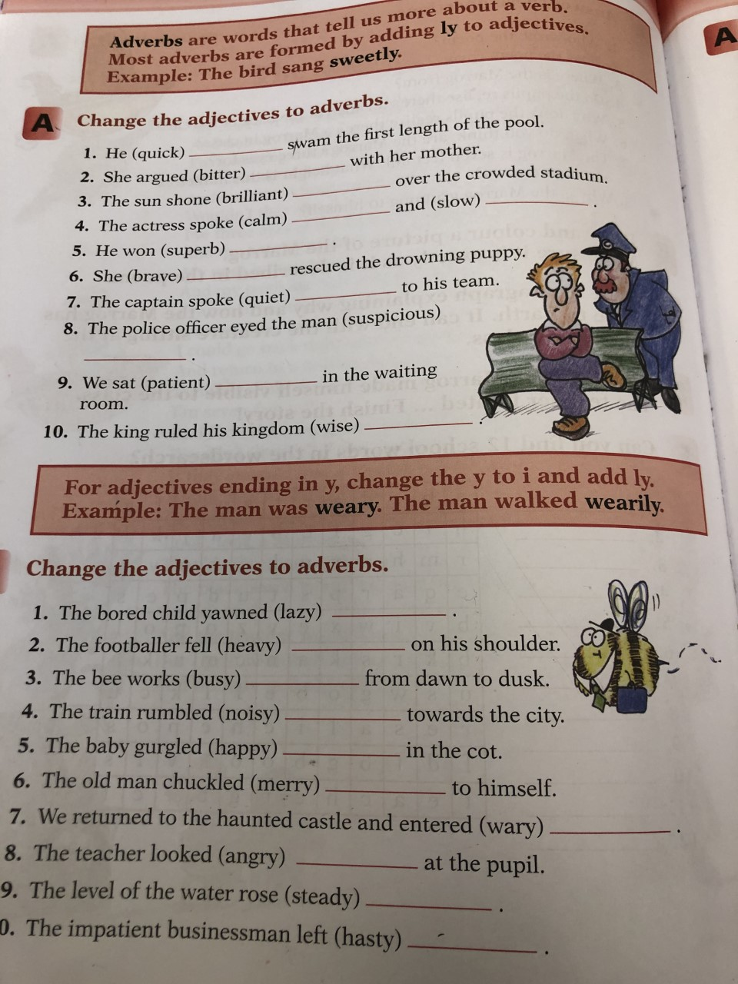

Personification -
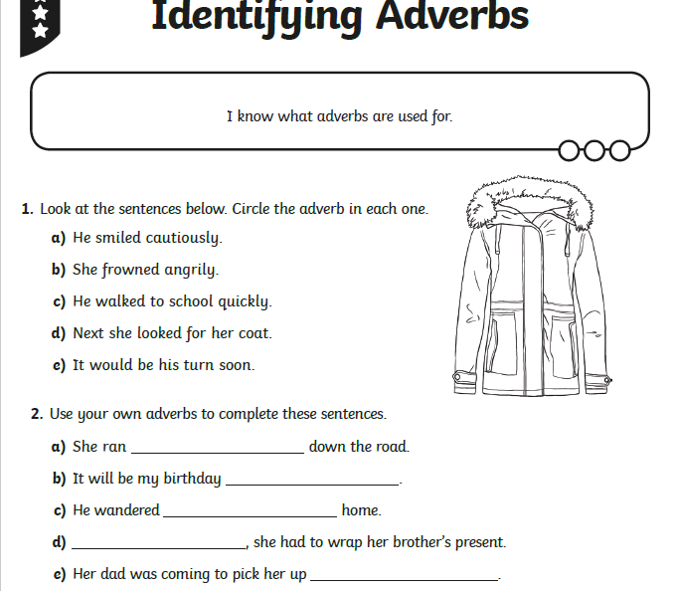

Simile -
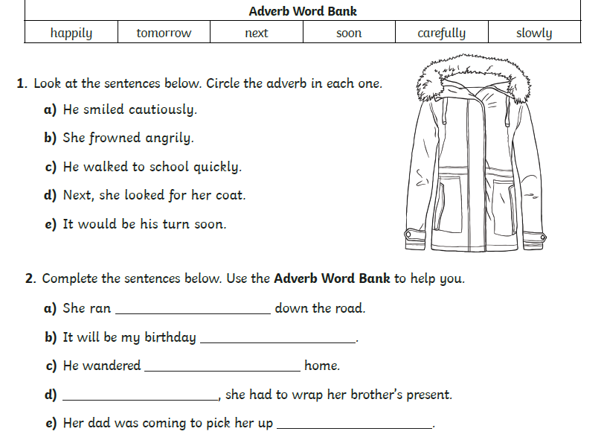

Maths
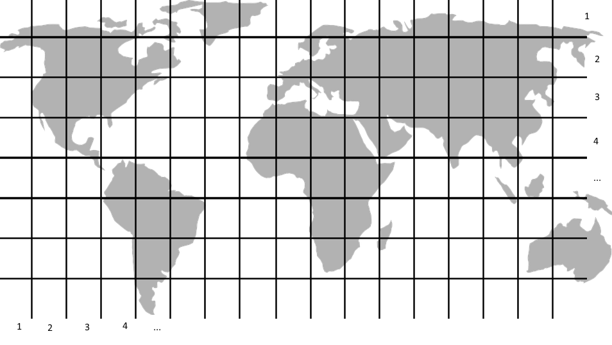
L.I To write, identify and find coordinates
Warm up: Play the following ICT Game. Remember the rule for coordinates (along the corridor and up the stairs). This means that if the coordinate is (4,2), you would go 4 along the bottom first and then 2 upwards. There are different levels. I’d suggest starting with mild and building your skill level up.
Mild – Beginner/Easy
Spicy – Easy/Medium
Hot – Medium/Quadrant II
Scorchio!– The sky is the limit, how far can you get?
https://www.mathsisfun.com/data/click-coordinate.html

Number Ninjas/ Maths Magicians – Task assigned for you in Teams
Open your task and look at the pirate map.
- Find the coordinates and write down in your jotter what can be found at each one. For example, at C,3 you will find a pair of pirate boots!
- Write the coordinates of the items shown in your jotter
- Have a go at drawing the pirate map and plotting the points
Take a photo and turn it in under assignments.
Mathletes - Task assigned for you in Teams.
Carefully draw a 10 by 10 grid in your green jotter (remember to use a ruler). Then, plot all the points and join them up. What emoji character do you get?
Take a photo and turn it in under assignments.
Time to spare? Why don’t you also add some colour to your picture?
Algebros - Task assigned for you in Teams
Draw the 10x10 grids in your jotter carefully using a ruler. Plot the points and join the dots together. What shape does it make?
Scorching bonus task: Use a ruler and measure the perimeter of your shape!
Take a photo and turn it in under assignments

Fun Finishing Task
Open ‘Spot the Ball’ assignment and play it with someone else in your house. Take turns to chose a coordinate each. Who will find the ball?

Topic
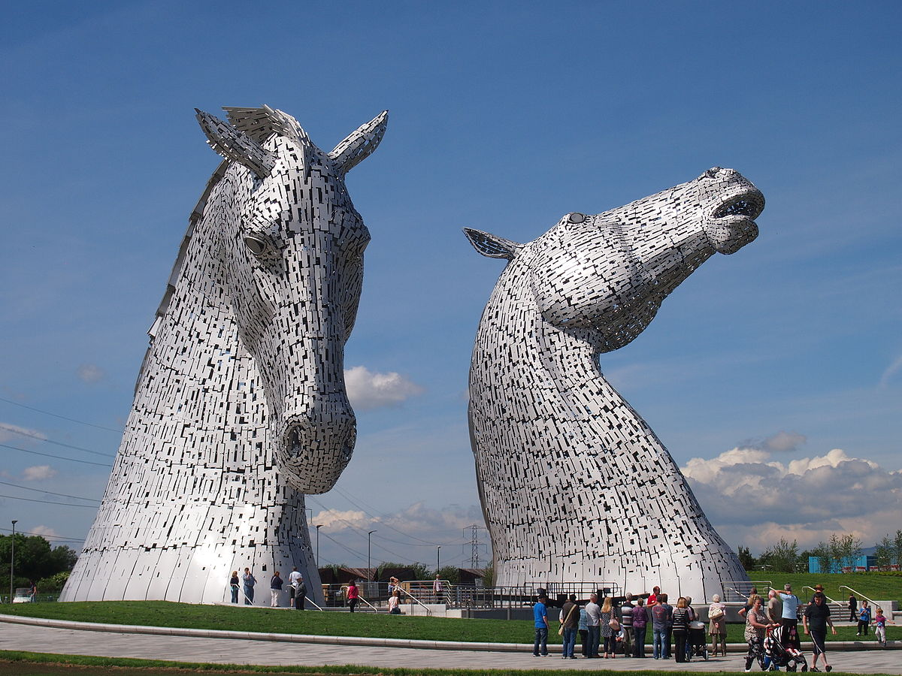
Please continue the research task you were given on Tuesday. Here is the information:
L.I. To explore a Scottish historical figure
Research one of these famous Scottish figures from the past and create a powerpoint/ sway/ poster displaying your findings.

William Wallace
Robert the Bruce
Mary Queen of Scots
Bonnie Prince Charlie

Some information you may want to include:
When did they live?
What are their achievements?
Did they face any struggles or setbacks in their life?
What has been their impact on Scottish history?

You have until Tuesday 31st of March to complete this task and share your work with your teacher.

