Wednesday 24.3.20
Please remember!
- Work can be completed in your green jotter or on a device/laptop
- You do not need to post on teams to say you have completed a job (we trust you!)
- The online chat is only to be used for questions
- Your teacher will only be available between 8.45 – 3.15 , no posts after that time. Break and lunch times still apply
- Do not put too much pressure on yourself to finish things quickly, these can be done throughout the day
- Remember you have access to apps and links such as Sumdog, Go Noodle and Activelearn. You can play these any time!
- If you finish all the tasks that we have set you can read, or decide what else to do with the rest of your day
- Try to post work in ‘assignments’ or ‘class notebook’ if you can’t do this, don’t panic. You can always upload a photo to the live chat... but you don’t have to!
Here are your jobs for today:
Literacy – Comprehension
Buzz Aldrin comprehension – LI: to read for information about an astronaut
Below there are passages and questions all about Buzz Aldrin.
You can choose *(mild) **(spicy) ***(hot) passage and questions

Mild passage and questions *
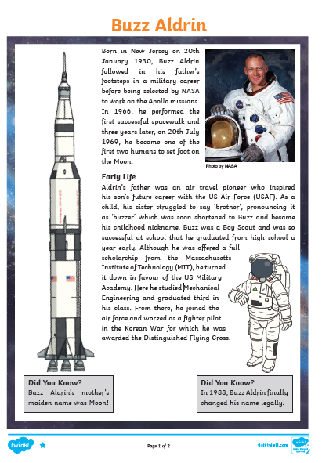
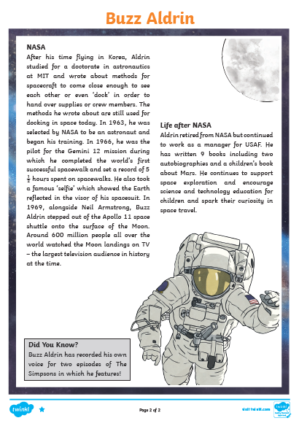

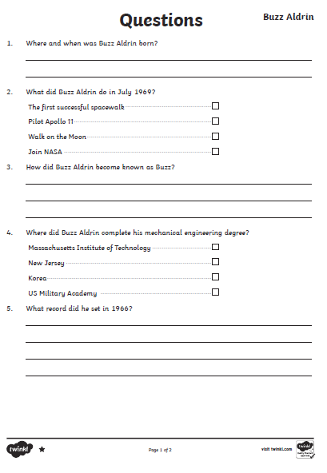

Spicy passage and questions **
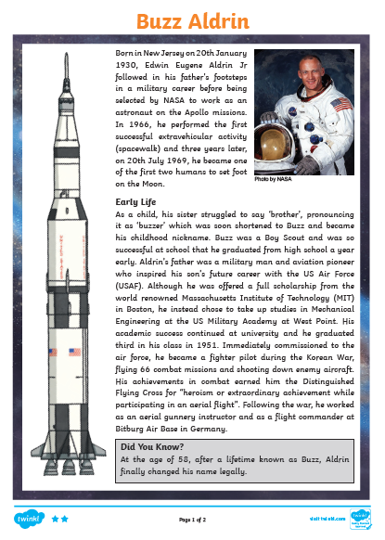

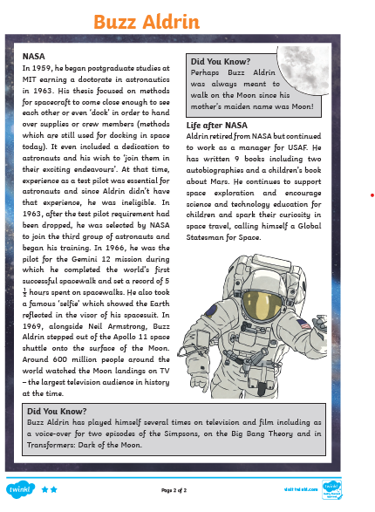
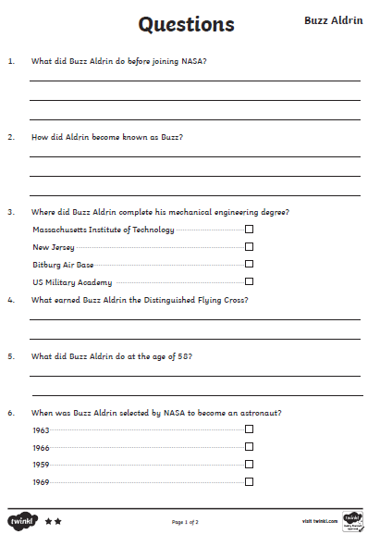
Hot passage and questions ***
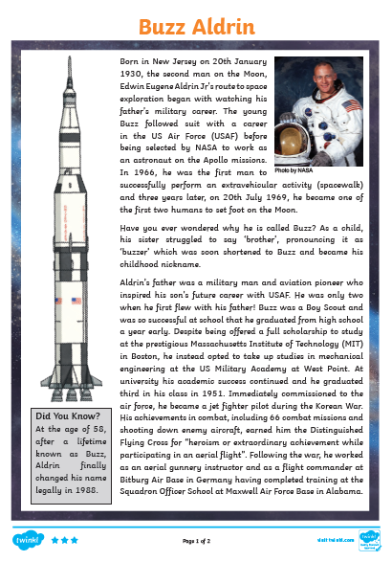
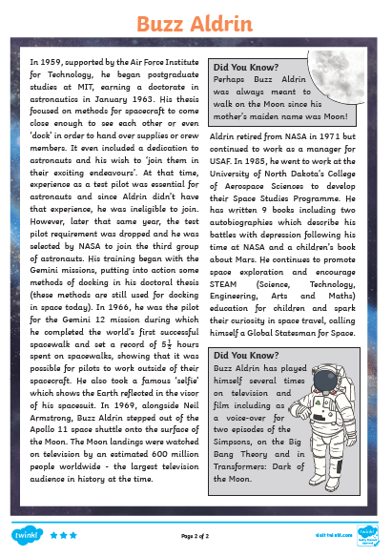
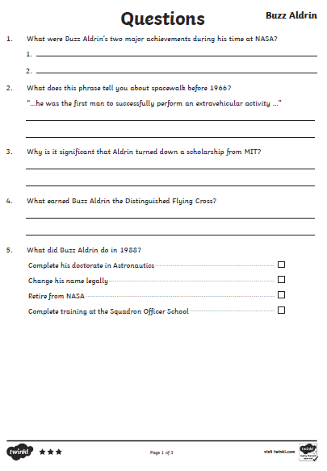

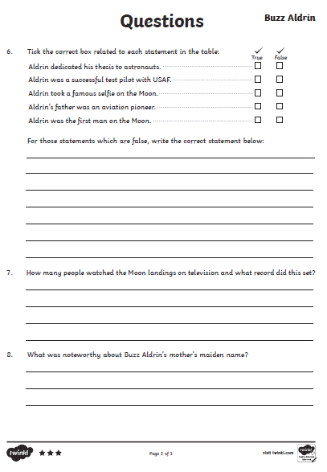
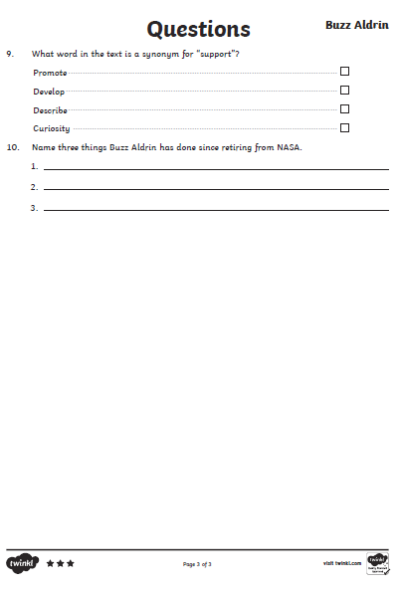

Numeracy - Other tasks will be posted by Mr Muller today 😊
- Finish and self-mark pages given yesterday (You have until Wednesday to complete).
- SumDog
- Active Learn Games
Additional Tasks
Mild- Place Value Revision- Try the game below. You can choose your own level of difficulty.
https://www.topmarks.co.uk/learning-to-count/place-value-basketball
Spicy-Fraction Revision- Try the game below. You can choose your own level of difficulty.
https://phet.colorado.edu/sims/html/fraction-matcher/latest/fraction-matcher_en.html
Hot- Fractions, Decimals and Percentages Revision- Try the game below. You can choose your own level of difficulty.
https://mathsframe.co.uk/en/resources/resource/120/match_fractions_decimals_and_percentages#.UCdcd2MsCEY

Art Task - L.I. To use line to create detail and shading
S.C. I can use line to ad detail/ I can add shading to give a sense of depth
- Have a look at pictures of rockets or satellites on line. What features do you notice? Really look at the details closely.
- Using a sharp pencil, VERY LIGHTLY, sketch out the outline of your drawing. Try to fill all the space you have.
- One you are happy with your sketch you can then go back over lines, darkening them or rubbing out as necessary.
- Remember to add the detail – that is part of today’s success criteria. Look for patterns.
- Now you can add shade. Use the side of your pencil for this.
Here is a youtube tutorial that can help if you get stuck –
https://www.youtube.com/watch?v=wYxChAB7k3E
https://www.youtube.com/watch?v=ByRpvEhpFbw

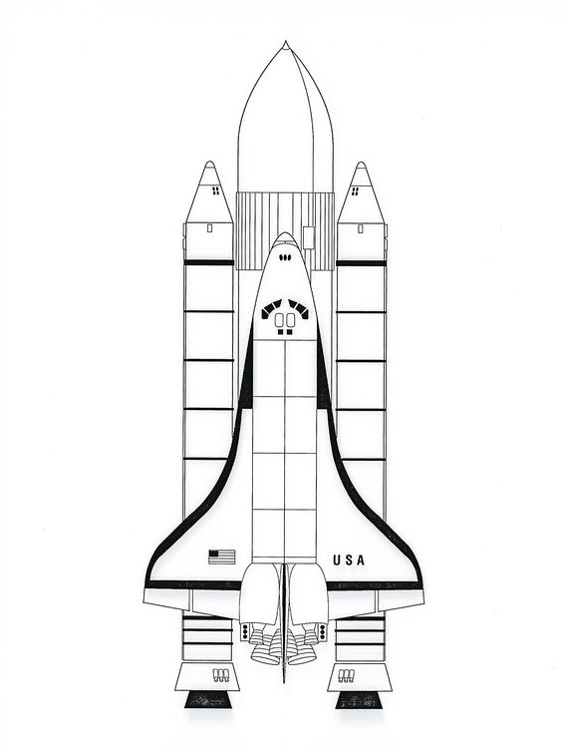
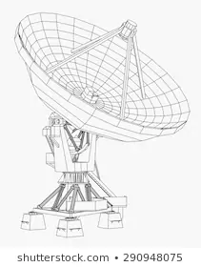

P.E – To develop skills for Hockey

If you haven’t already joined in with the Joe Wicks morning workout, here is a work out designed especially for hockey players.
https://www.google.com/search?q=how+to+do+hockey+from+home&rlz=1C1CHBF_en-GBGB818GB818&oq=how+to+do+hockey+from+home&aqs=chrome..69i57j0.5252j0j9&sourceid=chrome&ie=UTF-8&safe=active&ssui=on

This is a link to the Women’s World Cup Hockey Match between England and Netherlands.
https://www.youtube.com/watch?v=J-qiM7S6-iA
You don’t need to watch the whole match but skip through parts of it and think about these questions –
1/ Which team do you think displayed the best teamwork?
2/ Which team had the better strategies?
3/ Do you think the best team won?
4/ Did you spot any of the skills we have been working on in school? If so what skills did you see?
5/ Can you think of any other sports which use the same skills?

