Literacy - Writing

In class we have been developing our understanding of writing Narratives. Narratives are fiction pieces of writing designed to entertain and tell a story. We have explored Sci-Fi genre narratives and Horror genre. Today we will be writing a Fantasy narrative. Fantasy genre narratives are stories about imagined places and people. They are not based on real life in any way. It is a story set in a whole other world with fantastical creatures, events and magic. An examples of fantasy stories would be The Hobbit, Harry Potter, Alice in Wonderland and the Chronicals of Narnia.

Your task is to write a Narrative in fantasy genre. Remember that a narrative has the following features:

A title - Give your story a name!

Orientation - Who, what, where, when, why. Use exciting adjectives to describe a character and a setting.

Complication - What happens?!?!? What goes wrong? Make it as exciting as possible.

Resolution - What happens to fix the problem?

I have attached a word mat with useful words which will help you write. I have also attached a writing page with a fantasy border if you would like to type your story. You can also write it in your green jotter. There is also a fantasy genre help sheet.
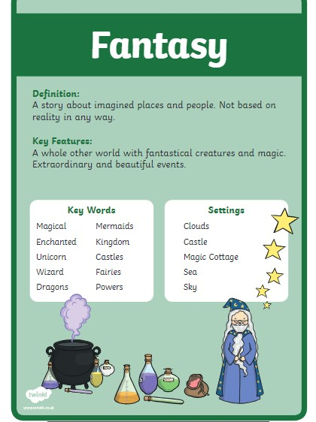
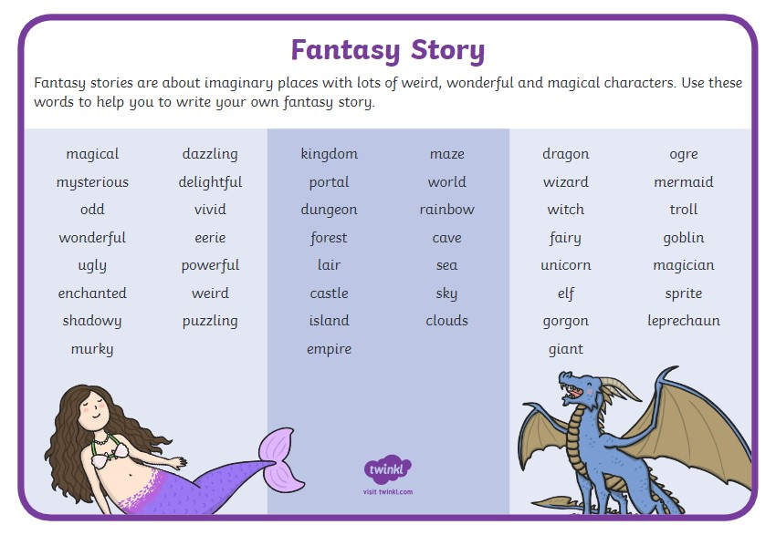
Numeracy

Squares – To divide by 9

Today squares I would like you to build on the understanding you developed yesterday to work on your division facts of 9. Remember, work out the multiplication and flip it round to work out the division.

Circles – To multiply by 9

Hello circles. Today we are going to continue to work on our multiplication facts of 9 so we can quickly recall them. Copy and complete these multiplcation stories of 9. You can do this in your home learning jotter or type them up on the word document below.

Triangles – To multiply by 9

We are going to continue your work from yesterday Triangles and practise our landing numbers for the 9 x table. Copy and complete the number sequences. You can do this in your home learning jotter or the word document I have added to the assignment

Topic

We have been learning about electrical circuits through our topic. It is important to consider safety when using electricity. We have attached an activity below.
