Williamston Primary School

Respect Responsibility Kindness

#BE THE BEST YOU CAN BE!
Curriculum Rationale
2018
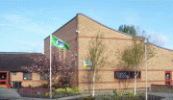
What is the rationale for our curriculum?

Our curriculum is designed to provide children with a broad, general education equipping them with the knowledge, aptitudes and skills they require to learn and live a full and productive life within their community.

The curriculum aims to ensure children can become more confident in their abilities and more open to new ideas, opinions and beliefs.

The curriculum aims to provide children with a wide range of learning experiences to support them in their physical, emotional and mental wellbeing and to offer opportunities to develop their ethical stance on world-wide issues.

OUR AIMS:
They are embedded in the principles of the Curriculum for Excellence and rooted in the 4 values of Scottish democracy.
Wisdom Justice Compassion Integrity

OUR SCHOOL VALUES:

All of our curriculum activities, programmes and opportunities for learning aim to provide our learners, parents and staff to develop and exemplify our CORE school values of

Respect Responsibility Kindness
- Respect for yourself, others and the environment
- Responsibility for all your actions
- Kindness Always.

Williamston Primary School has a whole school programme for Values education which supports the delivery of religious and moral education throughout the school.
Our values programme provides opportunities for Religious observance . The programme was established and consulted with pupils, staff and parents and our chaplaincy team to reflect the values of our community.
Our values programme activities include class assemblies, cluster assemblies and reflection spaces and classroom learning linking with Religious and Moral education programme.

The values programme is organised in a two- year cycle .

Curriculum Design

A curriculum fit for purpose for the 21st century needs to be flexible, creative and dynamic It needs to reflect the fact that we learn in a variety of contexts, through a variety of styles and that the world we are preparing our learners for is face paced and ever changing.
Our curriculum reflects that fact that we learn through all experiences not just in the classroom and that we aim to foster a desire continuing to learn through all con- texts to go with our pupils throughout their lives. Therefore we plan for and deliver the curriculum through the four contexts for learning as identified in Curriculum for Excellence.
We deliver Curriculum for Excellence through the 4 contexts
for learning
∗ Life and ethos of the school as a community
∗ Curriculum areas and subjects
∗ Interdisciplinary learning
∗ Opportunities for personal achievement
LEARNER PARTICIPATIION
PUPIL LEADERSHIP OPPORTUNITIES

CONNECTING CLASSROOMS PROJECTS
GLOBAL EDUCATION
INTERNATIONAL EDUCATION
LIFE AND ETHOS OF THE SCHOOL AND COMMUNITY

LEARNING FOR SUSTAINABILITY
Is at the heart of the Life and Ethos
of our school as a community

RIGHTS RESPECTING SCHOOL POSITIVE RELATIONSHIPS
RESTORATIVE PRACTICE

AFTERSCHOOL CLUBS and EXTRA CURRICULAR OPPORTUNITIES
ECO SCHOOLS
HEALTH PROMOTING SCHOOL
FAIRTRADE

NUMERACY AND MATHEMATICS

LITERACY AND LANGUAGES
Including English, Gaelic and Modern Languages
CURRICULUM AREAS AND SUBJECTS
Literacy, Numeracy and Health and Wellbeing – RESPONSIBILITY OF ALL

SCIENCES
RELIGIOUS AND MORAL EDUCATION

HEALTH AND WELLBEING

TECHNOLOGIES
SOCIAL STUDIES
EXPRESSIVE ARTS
PRINCIPLES OF CURRICULUM DESIGN

INTERDISCIPLINARY LEARNING

to explore a theme or an issue, meet a challenge, solve a problem or complete a final project.

develop awareness and understanding of the connections and differences across subjects or curriculum areas.

Williamston Framework for Interdisciplinary Learning

Most effective when
Meets learners needs
Based on Identified next steps
Involves learners fully in planning

DEVELOPMENT OF THE FOUR CAPACITIES- Attributes ,capablities and skills

OPPORTUNITIES FOR PERSONAL ACHIEVEMENT

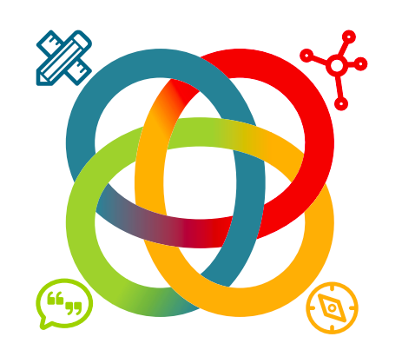
LEARNER PARTICIPATION
HOW GOOD IS OUR SCHOOL?
CONFIDENCE

RESILIENCE
MOTIVATION

