Williamston primary classes from September 2019 BOOKING NOW OPEN
Inspires Sports Coaching is a company dedicated to promoting and providing a high standard of sports coaching and activities to primary school children. Children will have a fun filled sessions which will also develop essential core skills such as balance, co-ordination and social skills as well as improving self-confidence & concentration.
Tuesday
Football P1/2 12.30-13.15 03/09-10/12
Football P3-5 15.15-16.15 03/09-10/12
Wednesday
Basketball P1-715.15-16.15 04/09-11/12
Thursday
Athletics P1-P7 (run, jump, throw) 05/09-12/12
Early booking is advised as class numbers are limited
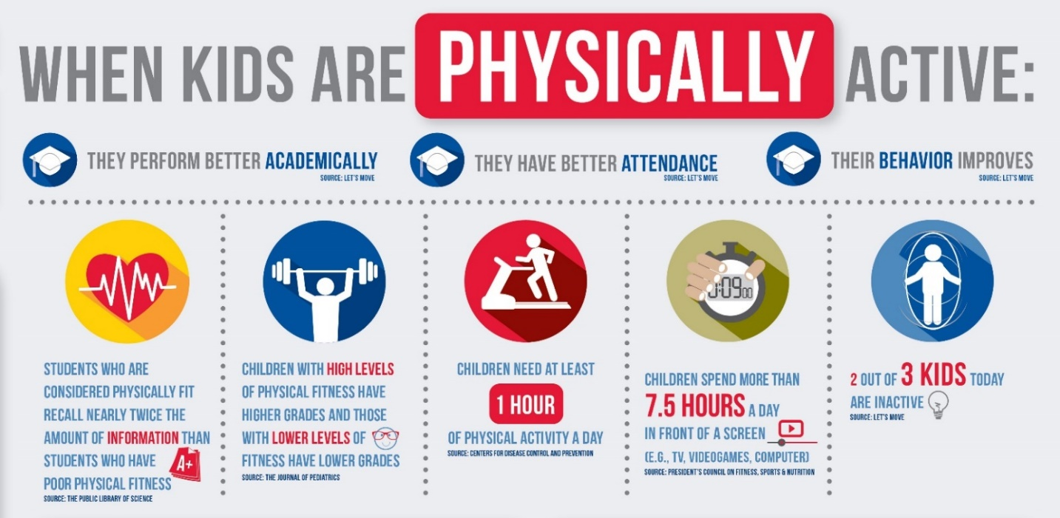
Start active | stay active
Inspire Sports Coaching
6 Redheughs Rigg | Edinburgh | EH12 9DQ
t: 07825 709151 | e: jc@inspiresportscoaching.org | www.inspiresportscoaching.org

