

Literacy

This term we will be looking at:

* Personal writing for yearbook
* Literacy Circles
* Summarising texts
* Inferring meaning in texts
* Fact and opinion within information texts
* Personal targets for next session
* Using connectives in our writing
* French

Health and Wellbeing

We will cover these areas this term:

* Keeping Myself Safe
* How a Baby is Born
* Fitness Fortnight
* Hockey skills
* Bikeability

Numeracy

This term we will be covering the following aspects of maths/numeracy:

* Measuring area and perimeter
* Measuring weight/volume/length
* Data handling
* Algebra and number patterns
* Written algorithms for 4 operations

measurin

**P7**

**Williamston Primary**

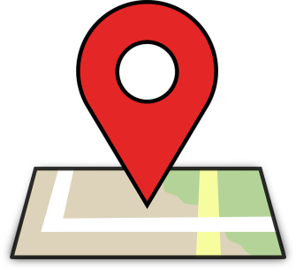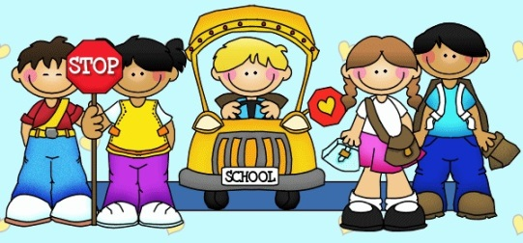**June 2017**

Across the Curriculum

In other areas of the curriculum we will look at:

* Climate, Land Use and mapping
* Classification, Food webs and Food Chains
* Animation
* Sketching skills in art