**Topic**

Our topic this term is The Magic Key. We hope the magic key is going to take us on lots of exciting adventures.

We will be developing skills such as:

* identifying the main idea of a story.
* expressing our feelings and opinions about stories.
* finding information from books/internet
* using our imagination to write our own adventure stories.
* including “wow” words in our writing tasks.



**Useful Class Information**

As we are taking our learning outdoors more often, could you please make sure that your child has the appropriate clothing. Thank you.

Here is a little summary of what is happening each week.

**Monday**

* **Homework handed out**

**Tuesday**

* **PE**
* **Art with Mrs Vest**
* **Visit the school library**

**Wednesday**

* **Music with Ms MacDonald**

**Thursday**

* **Drama with Mrs Thomson**

**Friday**

* **All homework tasks returned**
* **PE**
* **Golden time**

**Williamston Primary School**

**Newsletter for Primary 2**

**with**

**Mrs Lytle**

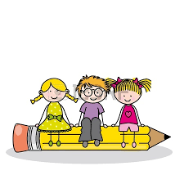

**Welcome**

**Numeracy**

We will be working with numbers within 100. We will be counting forwards, backwards, ordering, reading and writing these numbers.

We will be developing our mental maths strategies to help us find the answers to addition and subtraction sums as well as missing number sums.

In practical maths, we will be learning about 2D and 3D shape.

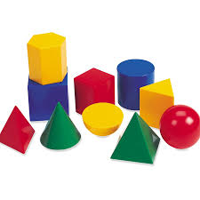

Dear Parent/Guardian,

Another busy term lies ahead of us and we are looking forward to sharing more of our learning with you. We are so grateful for all your support. The children are always so pleased to tell us about games they’ve played at home to help them with their sounds, reading and number work.

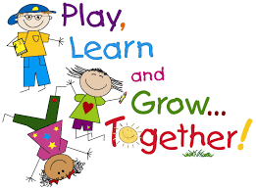

**R.M.E**

In RME, we will be learning about The Christmas Story. We will learn about Christmas traditions and will take part in whole school celebrations around the Christmas theme.

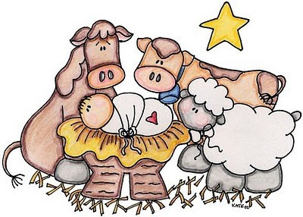

**Expressive Arts**

This term our Expressive Arts will be taught by the following teachers:

Ms MacDonald – Music

Mrs Thomson – Drama

Mrs Vest – Art

**Literacy**

Now that we have learned all our long vowel sounds spelling will become more formalised. Words will be sent home at the start of the week and will then be tested on a Friday. Spelling activities both in school and at home will still follow a multi- sensory approach. In writing, we are focusing on using “wow” words to help make our writing more interesting. In reading, we will be developing fluency and using punctuation to help us read with appropriate expression. We will continue to share our thoughts and our ideas about what we have read.

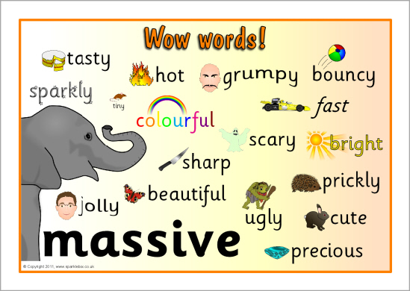

**Health and Well Being**

This term we will be learning all about our bodies. We will be focusing on the inside of our bodies as well as thinking about what we can do to keep ourselves healthy.

In P.E. we will be learning a Scottish dance which we will then perform at our Christmas party.

[](http://www.google.co.uk/imgres?q=happy+face&hl=en&qscrl=1&rlz=1T4ADRA_enGB403GB404&biw=1366&bih=641&tbm=isch&tbnid=_7A6XmYjhj8k8M:&imgrefurl=http://bokertov.typepad.com/btb/2011/08/in-what-al-reuterscalls-a-rare-dose-of-good-news-only-395000-new-claims-for-unemployment-benefits-were-filed-last-week.html&imgurl=http://bokertov.typepad.com/.a/6a00d83451bc4a69e2014e8a8f894b970d-800wi&w=380&h=380&ei=xR5FUJSiCImV0QWc-YDIDw&zoom=1&iact=hc&vpx=165&vpy=164&dur=1771&hovh=225&hovw=225&tx=175&ty=106&sig=111979208418497978607&page=1&tbnh=118&tbnw=118&start=0&ndsp=23&ved=1t:429,r:0,s:0,i:136)

**Communication**

If you have any questions or queries, please do not hesitate to put a note in your child’s reading record. Alternatively, feel free to arrange an appointment at the office to meet with Mrs Hollands or Mrs Lytle.