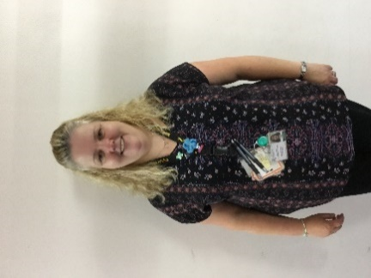 |  | 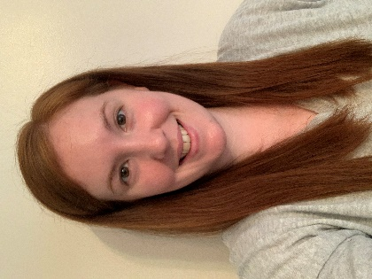
Evelyn Kitchin  Early Years Officer  (Mon-Fri) | Alex Baker  Early Years Officer  (Mon, Tue, Fri) | Morna Anderson  Early Years Officer  (Wed, Thu, Fri)
 | 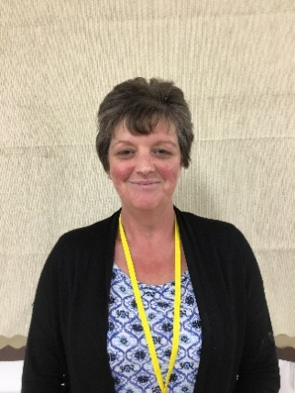 | 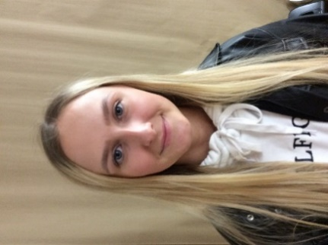
Lynsey McQuade  Early Years Area Support Manager (ECASM) | Karen Galbriath  Early Years Practitioner  (Mon-Fri) | Sarah-Jayne Copland  Early Years Practitioner  (Mon-Fri)
 | 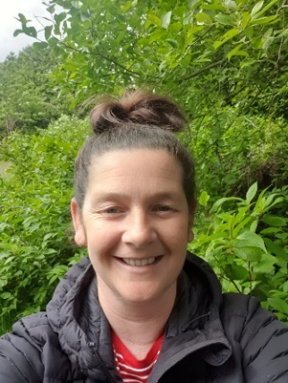 | 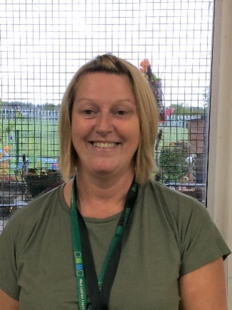
Jillian Haston  Early Years Practitioner  (Mon-Fri) | Sarah Swanson  Early Years Practitioner  (Wed, Thu, alternate Fri) | Lorraine Whatcott  Early Years Practitioner  (Mon, Tue, alternate Fri)
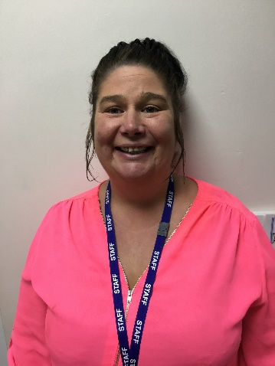 | 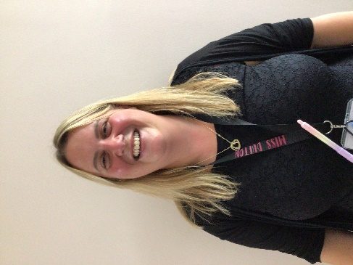
Carolann Swanson  Pupil Support Worker  (4-6 pm Tue-Fri) | Linsdsay Dufton  Pupil support worker  (4-6pm Mon)

