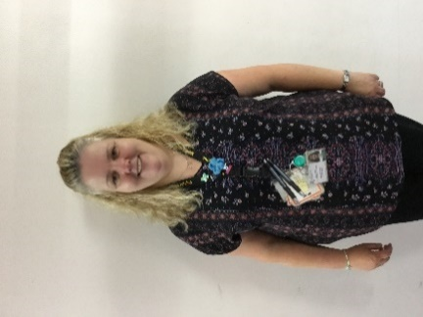
Our Staff
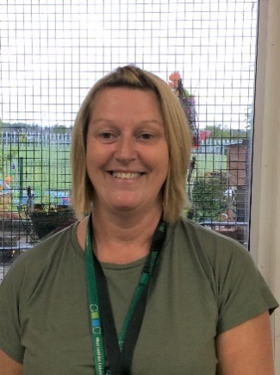

Miss Kitchin Miss Haston Mrs Whatcott
Early Years Officer Early Years Practitioner Early Years Practitioner
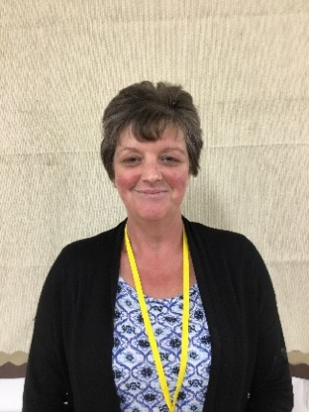
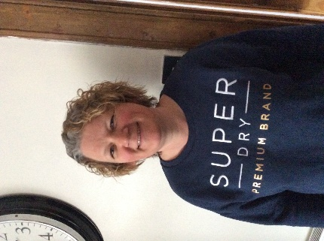
Mrs Galbraith Ms Dillett Ms Swanson
Early Years Practitioner Early Years Practitioner Early Years Practitioner
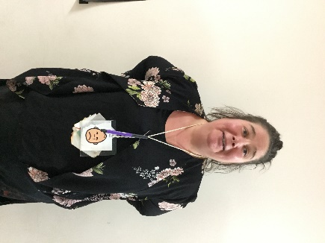
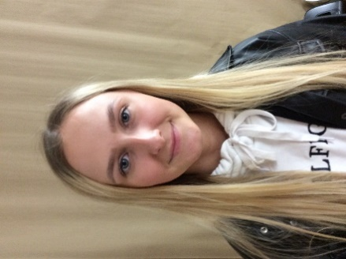

Mr McNab Miss Coupland Ms Swanson
Early Years Practitioner Early Years Practitioner Pupil Support Worker

