WELCOME TO OUR PLAY AT HOME Peep group



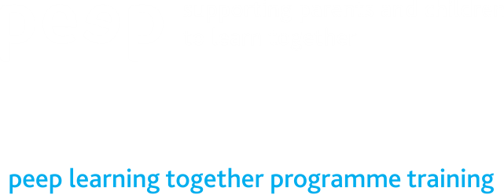copyright-peeple-03.png

**Peep supports parents and carers with children aged birth to five in encouraging your child’s learning and development.** You can make a real difference just by talking, singing, sharing books and playing together with your child.

**Things have changed for us due to Coronavirus and lockdown. We can no longer have our Peep group running in school. We thought it would be a great idea to try and have HOME PEEP which you and your child can do together. Every month we hope to provide handouts and resources to help and guide you to work alongside your child to continue to build on the relationships you already have.**

Peep is built on 4 main principles ORIM:

Opportunities - Giving children opportunities to do or try things

Recognition – Recognising and valuing when children have learned or tried something new

Interaction – Doing things together – including talking, singing and playing

Modelling – How we do things – our actions, attitudes and behaviour

Here at ‘**Deans Primary Nursery Class’** we would like to share some peep ideas and resources to help you have fun at home with your child through singing, stories, crafts and activities.

For more details please speak to : Mrs Wilson or Mrs Lindie

*Who for:* All nursery parents and their children

*Where: Deans Primary Nursery Class Main Gate*

*When:* Initially Every Month starting in **November 2020**

*Days:* Monday/Tuesday

*Times:* Drop Off and Pick up

*To find out more contact us on:*