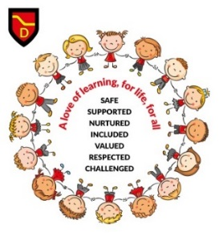

**Deans P1 Transition Programme 2019**

We want to give you as much notice as possible so below are some dates/events as part of our transition programme.

**Informal drop-in info sessions 30th April and 14th May @ 10.45am and 12.10pm**- an opportunity for you to ask questions about Primary 1 and get a look around the school.

**Transition information meeting for parents 23rd May @** **2pm** – short presentation about what to expect in Primary 1, time for questions with Mrs Wallace (Depute Head) and enrolment packs/paperwork will be distributed.

**P1 Play session** **6th June @ 1.30pm** – children spend time with their teacher and get to know classmates.

**Dine with us at Deans** **19th June @ 11.30am** – children and parents invited to experience lunch in our school dining room together.

**Bear and Buddy Picnic** **20th June** – (for children only) children will have a teddy bears picnic with their P6 buddy and get time to play with them and their classmates.

**How else are we helping your child prepare for P1?**

* Children are already visiting P1 classrooms and other areas of the school every week to help them become familiar with the school and its surroundings.
* The P6 buddies are visiting the nursery every week to help them prepare for their important role and have been ‘paired up’ provisionally.
* Children are spending time playing in the early years playground in preparation for break and lunch times.
* P1 staff will spend time in nursery getting to know the children throughout June