Snack Money | Can we remind everyone how important it is that we get snack money in for your child. We have the tin available every Monday for collection, or if you find it easier you can pay the full amount each term. Speak with staff if you are finding it difficult to pay.
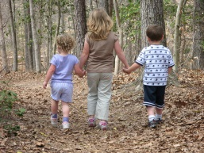  Weekly Walk | The nursery staff would like to say a big thank you to our small team of volunteers who help us with all sorts of things in our nursery. Now that we have help, we have started back on our weekly walk. We are able to take ten children each week out of school into our local community. Sometimes we go shopping, visit the chemist, have a look in the van who sells the fish! The children are only able to go if you have completed the EE2 form. Speak to staff if you have not already done this.
  Fundraising event, ‘Watch this space’ | As you know our nursery garden is used every day by most of the children. We are always trying to make this an interesting and fun area, with lots to do. The children especially love the bikes and we are now lucky enough to use them in the playground too. Unfortunately, they are becoming a bit ‘tired’ and we would like to be able to replace some of these. The children have also asked for an outside sandpit and now that we have our bigger garden this would be great for us. These things all cost a lot of money and we are going to do a sponsored walk out in the field area to raise some funds. This will be week beginning November 5th and your support in this will be greatly appreciated. We hope everyone can try hard to collect some sponsor money.
Displays | Come in anytime and have a look at our nursery. The children and staff are beginning to get the walls filled up with art work and photographs of all the fantastic learning we are doing.
Autumn Walk | Thank you to all who have joined in collecting things in the ‘Autumn’ bags. We now have all sorts of great things to see and talk about on our interest table. Many parents have commented about how much they enjoyed walking together with their children, finding signs of Autumn.

