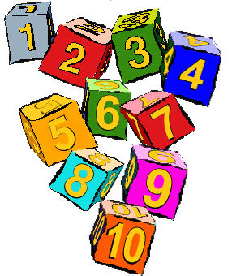  Numeracy | Our maths and numeracy week was a great success we practised counting in many ways for example using finger number rhymes. We also compared sizes and amounts. You can find the amazing photographs of some of our numeracy activities on our blog.
Health & Wellbeing | We have had to take away our sand, water and playdough temporarily as we have some children with upset stomachs in our nursery. If your child has been sick or has an upset stomach please ensure that you follow our sickness policy and keep your child off for 48 hours after last bout of sickness. As soon as we get the all clear we can bring back these activities.
Home/ Nursery Link | We will be looking for signs of autumn soon as part of our new topic. Next week watch out for your child bringing home a brown bag for autumn items. We would appreciate if you can collect sticks, leaves, conkers, acorns or anything to do with autumn when you are out for a walk with your child and return the full bag to us for discussion.
Volunteers | Thank you to those of you who have volunteered to help in the nursery. As you know any volunteers need to be disclosed and this can take a while. We are waiting for some disclosures to come through and this has meant some of our activities have been delayed. We will start the Weekly Walk and our Big Bedtime Read as soon as we can.
Stay & Play | We have our first Stay & Play on Wednesday 3rd October. Please come along at 10.15 morning session or 2.15 afternoon session if you can.
Friendship Topic  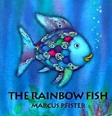 | We have been talking a lot about friends and being kind over the last few weeks. We have used the book The Rainbow Fish to extend this theme. If you get a chance please read it with your child and discuss the meaning behind the story.

