Overview of children’s learning 10.9.18
snack   | Due to our Asda delivery for Nursery being changed to a Tuesday, we will continue to offer our whole fruit day but it will need to be on a Tuesday.  Our Nursery team will be focusing on encouraging the children to be more independent in snack routines e.g . ensuring hands are washed before snack, encouraging the children to post their own snack cards, tidying away their empty plates and giving gentle reminders to wash their dishes.
Toileting | As you can understand, we have many new children started nursery. At the moment we are supporting a lot of visits to the toilet however, can we ask if you could please continue to encourage your child to be as independent as possible. Could we ask if your child could wear loose clothing to nursery making it easier for your child to manage a toilet visit by all by themselves.
Craft Area  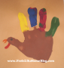 | We will be focusing on learning and re-visiting routines when we select to play in the art area. We will be encouraging and reminding your child to put an apron on before the activity. We will go over how to use a glue stick, what folder is for our art names and we will remind the children always to stick their name on their art work. We will be encouraging children to be creative and to take their beautiful masterpieces home.
Visits in School | We have lots of opportunities to use the primary school resources and areas. We have started taking our children to visit the library to look at some books and hear a story. We visit the sensory room upstairs which our children love and find relaxing and we visit the gym hall for some physical exercise and to play some games. We regularly go to the school office with our register, this is a good experience for the children to see other adults and children in the school.
Outdoor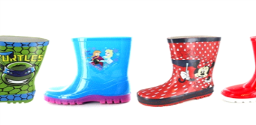 | Outdoors is an important part of our nursery, we like to encourage our children to experience the outdoor play as well as indoors. However, our focus just now is encouraging the children’s independence in putting on their wellies jackets and waterproof trousers before going out to play. We remind the children about keeping safe, taking turns and sharing toys.  Can I remind parents every child should bring a spare pair of named wellies including the new children so we are ready to go.

