Come along to a Peep group



copyright-peeple-03.png

**Peep supports parents and carers with children aged birth to five in encouraging your child’s learning and development.** You can make a real difference just by talking, singing, sharing books and playing together.

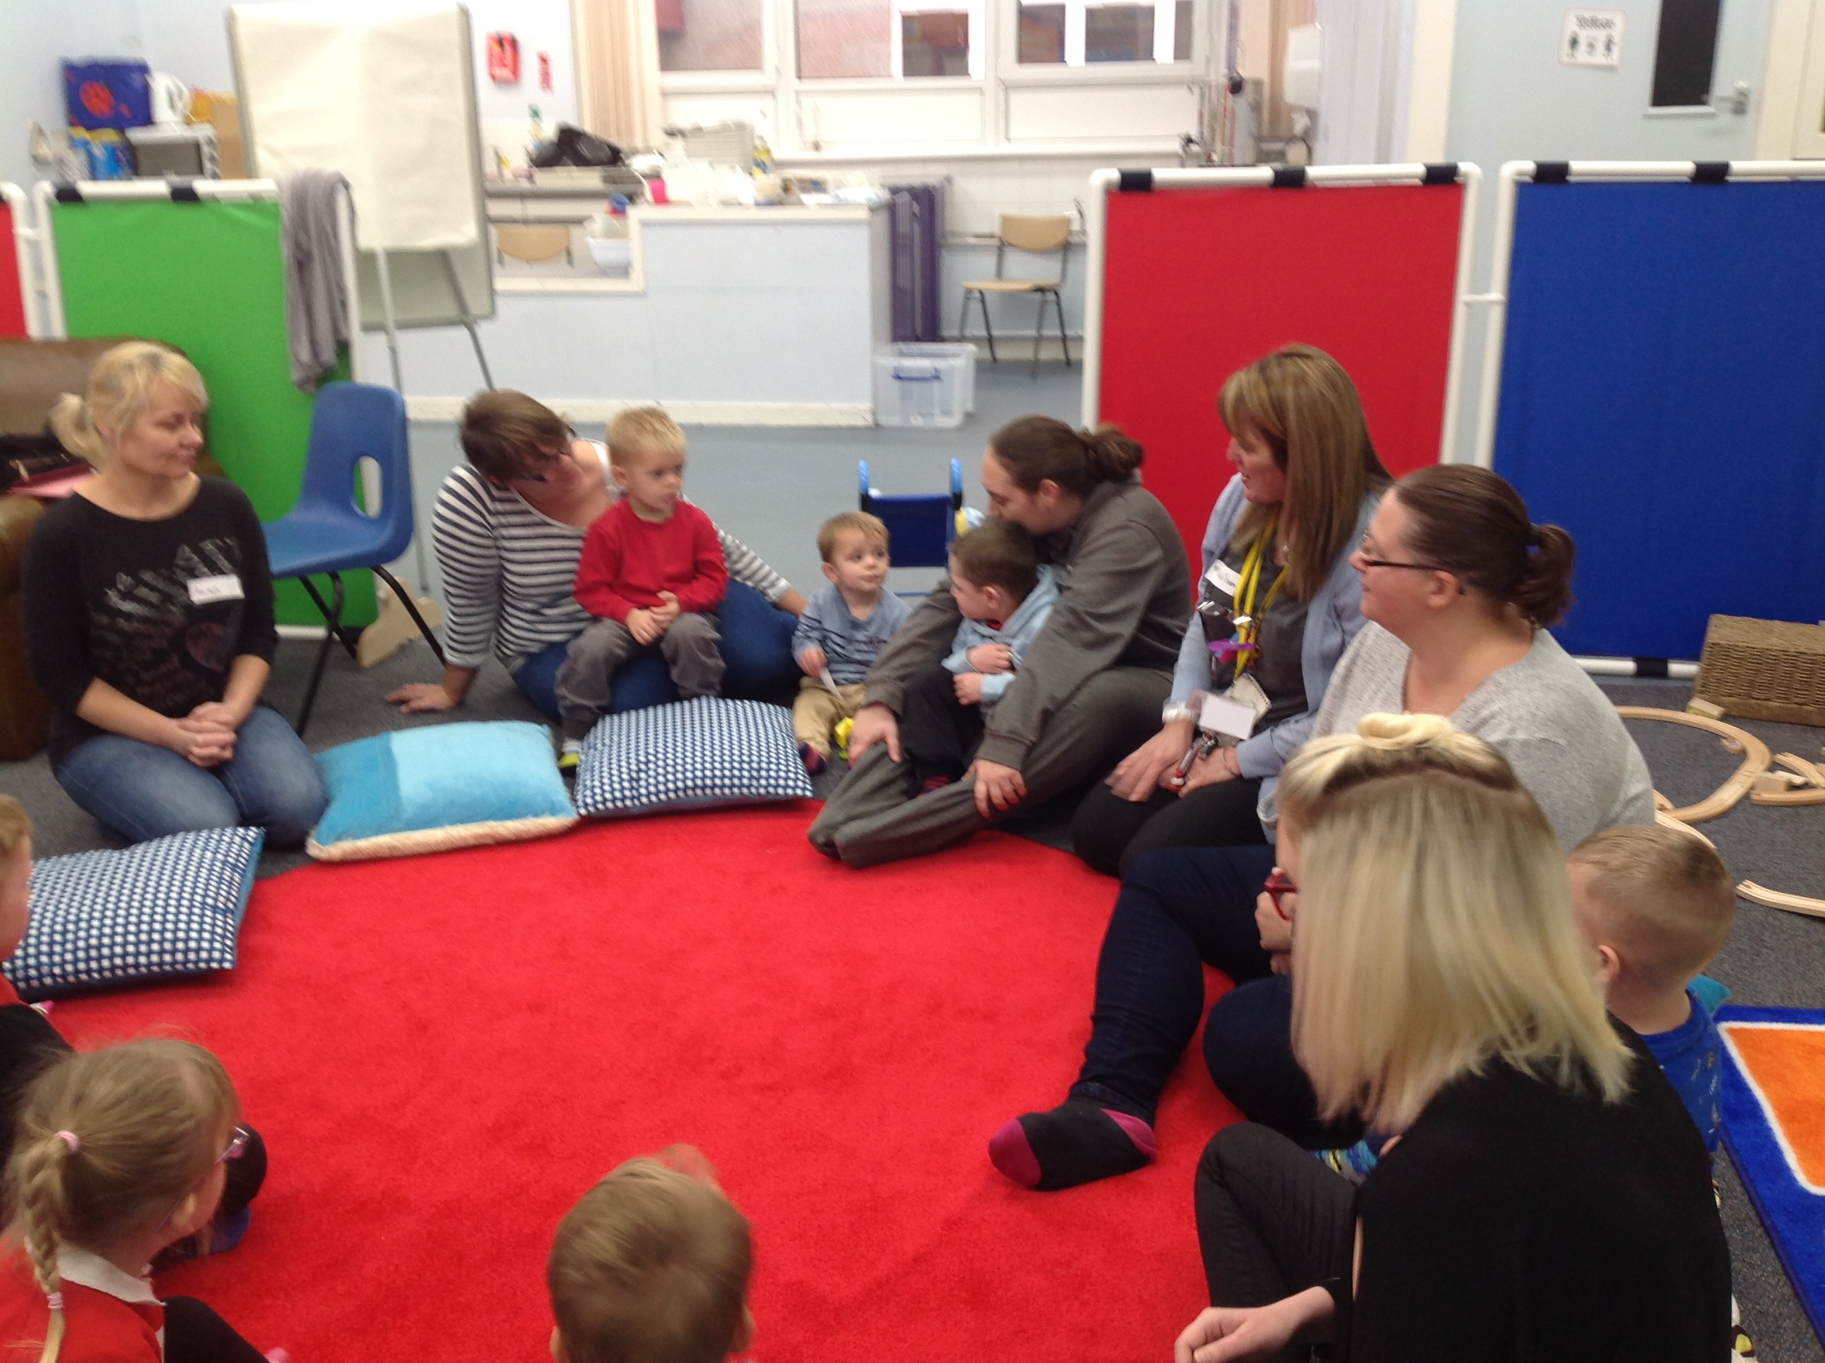

*Who for:* all nursery parents and their children

*Where: Deans Primary School (in PEEP room)*

*First day:* Wednesday 21st February 9.00 and 2.10

*Days:* Wednesday 21st 28th of February and 7th,14th,21st of March

*Times:* 9.00 to 10.00 and 2.10 to 3.10

*To find out more contact us on:*

Come along - you and your child can make friends, share ideas and have fun through singing, story and activities.