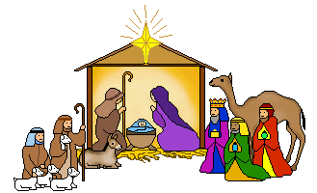
Costumes
The nursery is providing all the costumes for the Nativity performance but parents/carers can help by ensuring the clothes underneath the costume are suitable. Please wear these items underneath your child’s normal clothes on the big day!
Here is the list to refer to
Angels – white vest/T shirt, white tights/socks or shorts/light trousers
Shepherds/ Kings – plain coloured, round necked, short sleeved T shirt or vest (trousers as usual)
Animals (camels, horses, donkeys) – plain long-sleeved T shirt (grey, tan, black) and trousers (grey, tan, black)
Sheep – plain long sleeved white/black T shirt, plain black/white leggings/ trousers
Stars – white T shirt, white/black leggings/ trousers
Innkeepers – long-sleeved, round necked plain dark T shirt (trousers as usual)
If your child is uncertain about their role just ask a member of the nursery team. Also if you have any issues with sourcing these items please speak to us and we will try to help.

