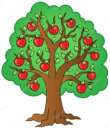  Snack | Last week the children noticed there were lots of apples falling from our apple tree in the nursery garden. They ‘harvested‘ the apples (see BLOG) and this week we chopped and cooked them and put them in a pie to eat at snack. Yummy……….
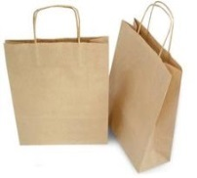  Outdoor Learning | As usual there is a massive amount going on outdoors in our nursery garden. You can also get involved in your child’s outdoor learning by going an autumn walk with them. Every child has been given an autumn walk bag for any autumn items spotted on your walk. Return the used bag to us (name it too please) and we will share this learning next week.
Home School Link | We have created our interactive display around our transport theme and copies of ‘The Wheels on the Bus’ have been put in the children’s pigeon holes. Don’t forget your autumn walk bags too.
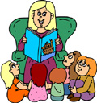  Group Time | We regularly have group time where the key worker works closely with her group. During this time we cover a variety of activities and topics. Over the next few weeks we plan to include number activities as well as a story.
Magic Maths | This week the children took part in a traffic survey from our nursery garden. They had a simple chart where they added ‘tally marks’ for different types of transport and a chart for different colours of cars. The focus on their task was impressive!
Our Great Idea Book | We have bought some lovely ‘Great Idea’ books for recording the children’s ideas and thoughts. If parents/carers would like to add to the current book, we would be delighted. For example, maybe your child has mentioned they are looking forward to travelling on a plane or particularly like scooters - jot it down for us all to share.

