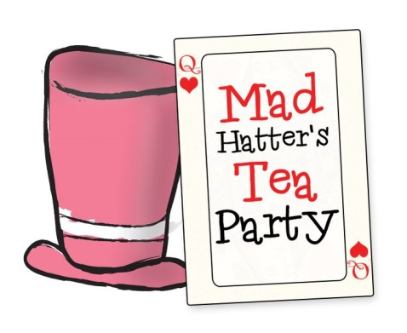

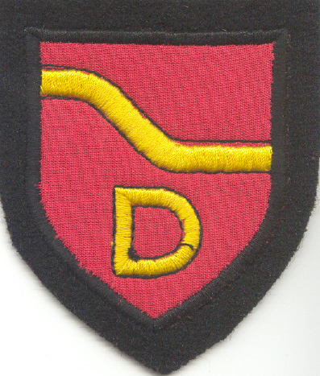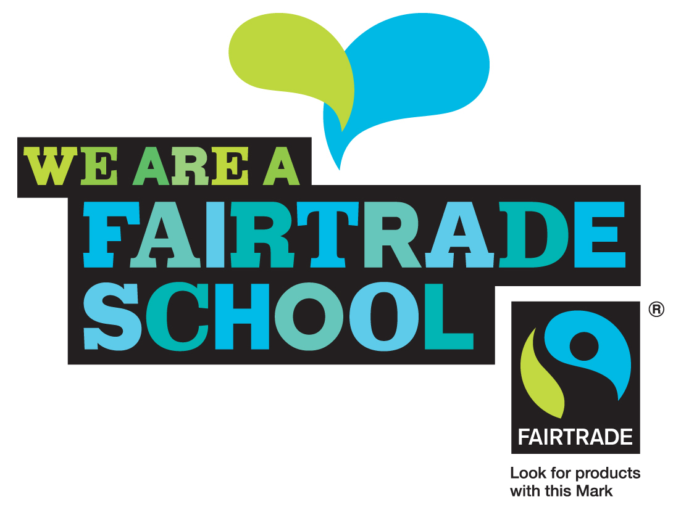

We’re going mad for MacMlillan!

We are hosting a mad hatter’s tea (and coffee!) party to raise money for MacMillan Cancer Support on Friday 29th September. Pupils can come to school wearing their maddest hat, hairpiece or hairstyle! We would love for parents, carers, family and friends to pop along and join us for cake and a cuppa (for a small donation). Below is the timetable for when classes will attend the tea party but you are welcome to join us at any time! Nursery children need to be accompanied by an adult.

|  |  |
| --- | --- |
| Time | Classes |
| 9.10-9.30 | P1C and P1F |
| 9.30-.9.50 | P2 and P2/3 |
| 9.50-10.20 | P3 and P4 |
| 11.00-11.20 | Nursery |
| 11.20-11.40 | P5 |
| 11.40-12.00 | P6 |
| 12.00-12.20 | P6/7 and P7 |

Donations of cakes and home baking would be appreciated and should be sent in the day before or on the morning of Friday 29th September. (Please label any home baking with possible allergens e.g. nuts, eggs, gluten etc)

We look forward to seeing you!