Food Safety & Healthy Eating Policy

Parents, staff and children were consulted in the formation of this policy.

HEALTHY EATING POLICY

Aim:

Our weekly menu will provide children in our care with a tasty, varied and healthy diet. We serve only foods that give children lots of nutrients and are low in sugar or salt, for example bread, cereal (with little or no sugar), fruit, vegetables, milk and milk products. The only drinks offered at snack time are water or full-fat milk.

- We will use best practice guidance (in particular Setting the Table - Nutritional guidance and food standards for early years childcare providers in Scotland )when planning our menus.
- The weekly snack menus will be on display in the cloakroom area.
- Snack will usually consist of 3 choices (two made up of fruit or vegetables and one starchy food, dairy (cheese and yoghurt will also feature regularly).
- The weekly menu will provide children with a varied diet (see appendix for examples of the foods given to the children).
- Children will help to prepare the snack menu each week by making suggestions/requests. This will allow discussion around healthy and un healthy foods.
- All the children will have suitable food available for them.
- We will offer breakfast.
- All dairy products will be full-fat.
- Milk or water will be served during morning and afternoon snack.
- Water will be available at all times.
- Parents will be advised if their child is not eating well, through a daily self check method.
- Parents of children on special diets will be asked to provide as much information as possible about suitable foods and in some cases may be asked to provide the food themselves.
- Children will be encouraged to develop good eating skills and table manners and will be given plenty of time to eat.
- Allergy information will be displayed for all food served.
- Good teeth brushing habits will be encouraged.

Adapted from: Setting the Table; Nutritional Guidance and food standards for Early Years childcare providers in Scotland. (NHS, Health Scotland, 2015).

FOOD SAFETY POLICY

Control Points and Procedures

Purchase and Delivery

- Milk will be delivered by 'Wiseman Dairies' and brought to the nursery class by the janitor or placed in the fridge in the main school kitchen, to be collected by a member of the nursery team.
- Once in nursery, the milk will be probed by the member of staff who will record the temperature and put in the nursery fridge (if it falls within the desirable temperature range or reject it and notify management if it doesn't).
- All food to be purchased from a reputable supplier e.g. Morrisons, Asda, Scotmid, Tesco - sell by dates must be checked on delivery and before use.

Chilled Storage

- The temperature of the fridge and milk should be tested using the digital probe and cleaned with a bacterial spray/probe wipe, both a.m. and p.m. This must be recorded in the temperature control sheet. The temperature should be 5 degrees ideally but certainly should be between 2-8 degrees. Management should be advised of any deviance from this.
- Milk is to be stored at/below 5oC but at no more than 8oC.
- Food should be covered or wrapped once opened and should be clearly labelled indicating date opened and best/used before date.
- The freezer should be de-frosted at the end of the term and the fridge cleaned weekly. Ensure door seals are cleaned. (top and bottom)
- The food probe thermometers are regularly checked for accuracy. This will be carried out by probing the freezer and boiling water to verify temperatures of 0oC and 100oC respectively. Results will be recorded monthly on the probe record sheet.

High risk foods, such as
- All cooked meats and poultry
- Cooked meat products, including gravy and stock
- Milk, cream, artificial cream, custards and daily produce
- Cooked eggs and egg products e.g. mayonnaise
- Shellfish and other seafoods
- Cooked rice
should be stored and used as per manufacturer’s instructions.

Food Allergies and Food Intolerances

- A Poster will be displayed providing information on the 14 allergens that need to be identified if they are used as ingredients as required by EU law.
- Information regarding allergenic ingredients used in foods purchased will be listed clearly and available on request.
- Individual's food allergies or dietary requirements will be clearly displayed inside kitchen cupboard along with the child's photograph. All supply staff will be made aware of where to find this information.
- During enrolment parents will be asked to inform staff of any food allergies, intolerances or special requirements.

Preparation

- Plastic wrapper should be removed from milk before being stored in the fridge.
- Food to be prepared on appropriate colour coded chopping boards and separate knives to be used to avoid cross-contamination. Follow cleaning schedule in food hygiene folder.
- Prepare Gluten Free food on separate board using clean utensils etc. Toast bag to be used in toaster - as and when required.
- Reheating: opened or decanted food must be brought up to a temperature of at least 82 oC and then left to cool to a safe temperature.

Personal Hygiene

- Staff to wear a disposable plastic apron, which is changed at the beginning of each session, or a fabric one each day, which is washed in washing machine.
- Staff and anyone helping with food preparation should wash their hands thoroughly using anti-bacterial handwash. Re-wash before preparing GF food.
- Anyone with long hair should have it tied back.
- If nail polish and hand jewellery are worn during preparation and handling of food, disposable gloves should be worn.
- Children will be taught the need for hand washing before eating. GF children to check no play dough left under nails.
- Adults with broken skin must wear blue plasters which can be found in the First Aid Kit.
- Teeth brushing routine in place after eating to develop good hygiene habits. GF food is high in sugar and fat so this is very important as tooth decay is high in children on a Gluten Free diet.

Washing-up / Cleaning

- In order to encourage self-help skills, children will put any leftovers in the food waste bin, milk cartons in the milk bin and plates/cups in the washing basin.
- Member of staff will then place dishes in dishwasher or wash plates and mugs in dish washing sinks using an anti-bacterial detergent (as per WLC guidelines), prior to stacking for drip drying.
- Sink to be sprayed with anti-bacterial solution.
- Work surfaces, splash backs and cupboard doors should be cleaned with hot soapy water and anti-bacterial spray and dried with blue roll prior to use.
- A high level of cleanliness to be maintained daily in kitchen area i.e. fridge and cooker.
- Floor to be swept as necessary using brush/pan in kitchen area.
- Mop/blue roll to be used for spillages.

APPENDIX 1: Food hygiene Certificates

APPENDIX 2: Setting the Table, Pages 50, 61, 62, 64, 100, 78, 79 Nutritional guidance and food standards for early years childcare providers. NHS, Scotland.2014

APPENDIX 3: Allergen information for loose foods. Food Standards Agency.2014

APPENDIX 4: 3 Week sample menu

APPENDIX 5: Kitchen cleaning Schedule.

APPENDIX 6: Temperature control sheet / Fridge /Milk from the WLC Food Safety Handbook 2003

Appendix 2
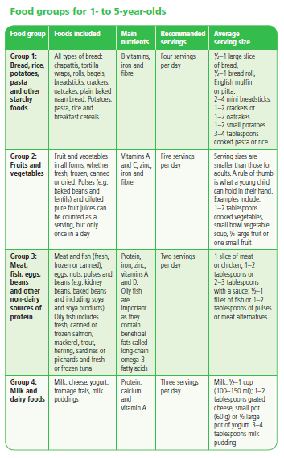p50

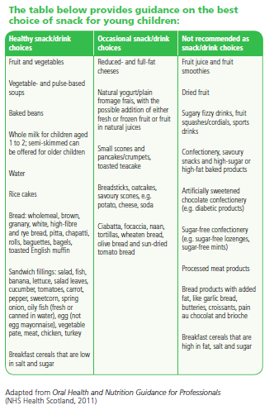p61

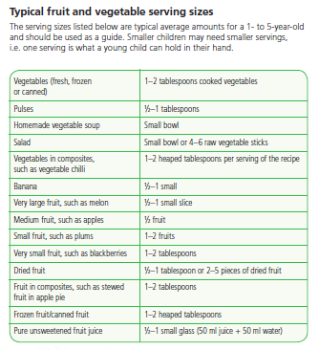 p62

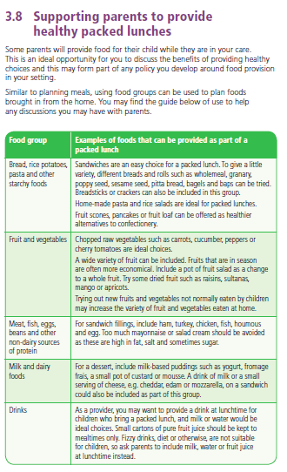

P64
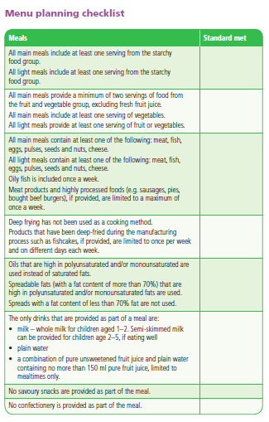
P78

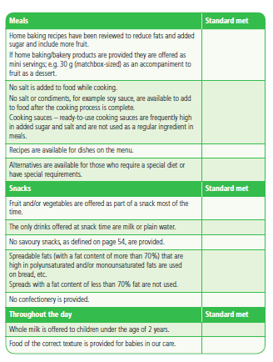

P79

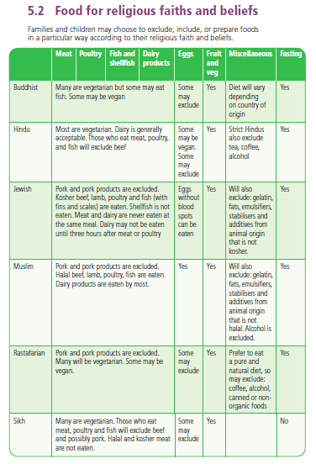p100

Appendix 3 Food Allergen information

