Multicultural Week     | As we have already had Scottish week this year, we wanted to raise awareness and celebrate other cultures with the children. Thank you to the two parents who came forward to participate in our multicultural week resulting in our main focus being Romanian and Polish. The children will have the opportunity to learn some simple phrases in these languages, try a small traditional snack, learn some facts about these countries and listen to traditional music. We continue to encourage you to participate by sending your child with a photo/flag etc. of your culture/cultural celebrations so we can introduce these also.
  Transition | This week the boys and girls going to Deans Primary will work alongside their buddy on a mini project that will provide information on them and their buddy. The idea behind this is that it will be taken home over the summer to continue to help prepare your child for their move into Primary 1.
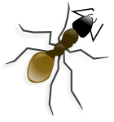  Science/Mini beasts | By using a talking box and 3D mind mapping method of planning, it has been identified that the children have an interest in mini beasts and would like to learn more. We will be taking this forward throughout the nursery and outdoor area, through information books, bug hunts and monitoring our bug houses outside etc.
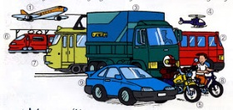  Transport | Through the planning, it also showed a slightly smaller interest in transport. Therefore we will also be adding some different transport based resources and monitoring their interest and follow accordingly.

