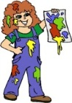  Craft | The children have been experimenting with using block paints. We are encouraging them to think and plan what they are going to paint; and use thinner brushes with smaller hand movements to help create their pictures. There has been a lots of boys and girls coming over to give it a try. This is great and we are seeing lots of good representation in the pictures which are being displayed.
  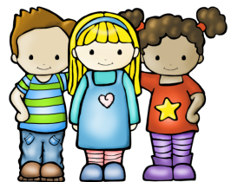  Transition | Transition is proving to be very successful. The children are very excited to see their buddies on a Tuesday and love visiting the Primary 1 classes on a Thursday. Soon the children will be starting to work on a mini project with their buddy, allowing them to get to know each other even better.
Enjoy-a-ball | The afternoon boys and girls are in the swing of their Enjoy-a-ball block. They are loving it! Through this, they are not only learning physical/gross motor skills, but also improving on their listening skills and turn taking skills.
Outdoor   | As always everyone is enjoying the good weather, which means lots of outdoor play. We have been promoting problem solving skills when using the tubes and stands to make a ball run. We are going to be promoting more independence with this activity. We also have had our musical instrument stand out so you may have heard some beautiful music on your way past the garden! We are planning on linking this with the outdoors, to see if the children are able to make music using natural materials and their outdoor surroundings.

