  Craft/Home Link | This week in craft we will be focusing on Spring. We will make pictures using a variety of different materials and make a Spring display. We would love it if you could get involved and when out walking, if you and your child could look for signs of Spring. To add to our display it would be great if you could take a photo or draw a picture of your findings and bring it in.
Transition | Visits to Primary 1 classes are going well. This week the children will be introduced to their special buddy who will help them during the transition process. Don’t worry if your child can’t remember their buddy’s name, as we will be making a ‘Me & My Buddy’ display.
  Music | We have some brand new instruments out in nursery, which have been very popular. As well as exploring how to use the instruments and their different sounds, the children have also been learning how to look after them. Don’t forget to listen out for our beautiful music when in nursery.
Outdoor/Science | Planting has proven to be very popular and will be continued this week, as well as watering the seeds/plants. The ladies have been trying to tidy the garden up and the children have been very keen to help. We ask that you send your child in clothes that are allowed to get dirty, allowing the children to follow their interest.
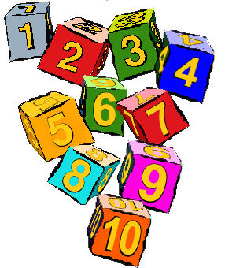  Number/Games | There has been a lot of talk about colours and patterns using the coloured cubes. The children have been independently exploring making repeating pattern towers. We will be carrying this interest forward and looking into where else we can introduce pattern throughout the nursery.

