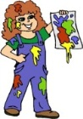  Craft/Home Link | The children are loving using different techniques to create Spring pictures. Lots of flowers and sheep have been made and are already up on our Spring display. Remember we would love you to get involved by helping your child spot signs of Spring when out and about and bring in a photo or a piece of art (of their findings) to add to the display.
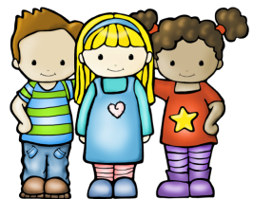  Transition | Primary 1 transition is going great. Everybody has been paired up with their buddy and lots of nice play and interactions have been taking place. Please make sure you take a few moments to look at our ‘Me & My Buddy’ display so you are able to share this experience with your child.
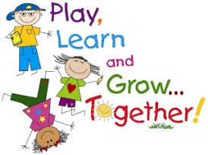  Tactile | We have re-introduced water and sand, which is proving very popular. There are a number of everyday household objects in both trays, such as bowls, spoons, measuring jugs, cake cases, teapot etc. This allows the children to experiment and explore valuable skills they will be able to use throughout their lives as well as bring up a lot of mathematical language.
Literacy/Outdoor  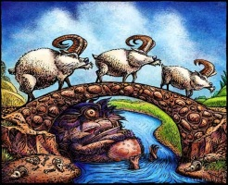 | Many children have been loving using our Three Billy Goats Gruff story box, allowing them to use props to help them independently tell the story. Some of us have also been using the wooden crate in the garden as a bridge and acting the story out for our peers. Story telling is a very valuable skill, so we are encouraging this and hope to explore other stories using these methods.

