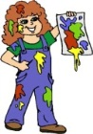  Craft | The children have enjoyed making junk models this week. Their designs have been many and varied. Please keep the junk coming in and remember toilet rolls and egg boxes are now allowed.
Transition | The children moving to primary one in Deans Primary School have already started their transition programme. They had great fun joining the primary one classes in the playground and classrooms.
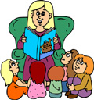  Group Time | We regularly have group time where the key worker works closely with her group. During this time we cover a variety of activities and topics. Over the next few weeks we plan to include discussions about spring time and growing plants.
Science | We plan to talk about plants and what they need to grow and flourish. Each child who wants to experience planting will get the opportunity to plant some vegetable seeds in an individual pot to be transplanted later in the garden.
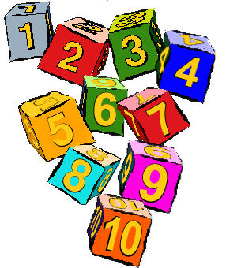  Number/Games | Some new dice number games have been provided and the children are enjoying playing them while practising their number pattern and number recognition skills. We plan to continue this next week moving towards more independent play when the rules are firmly established.
Outdoors | We have enjoyed outdoors this week despite the weather. We are very independent now getting ready and there are good examples of children helping each other too. Some children have been weeding the garden in preparation for some planting in the next week or two.

