  Recycling | We have been given new recycling bins throughout the school. This week the children will be working on getting to grips with separating their rubbish into the food, paper and general waste (“dirty rubbish”) bins.
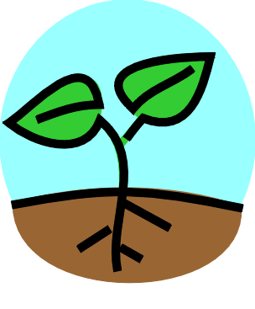  Outdoors | We are following the children’s interests outside which is going to keep us very busy over the next couple of weeks. Some of the children have been looking at the flowers that are growing in the garden, which has struck up an interest in planting. Others have been ‘painting’ with water and paintbrushes on the ground, so we will provide some paint, brushes and rollers outdoors for the children to experiment creating their art in different ways.
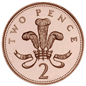  Role play | We are continuing our coin recognition through our shop role play. This is very popular and we need a constant supply of real money to make the experience as authentic as possible. If you have any spare ‘coppers’ please think of us.
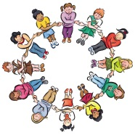  Group Time | We are focusing on name recognition and number activities in group time. The children are able to experience a variety of fun activities that will help them to build their knowledge and recognition of their names and numbers (e.g. writing their names using their finger in the rice tray.)
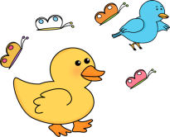  Spring/Easter | Throughout this week we will be starting to talk to the children about the change in season and Easter. We are going to be asking the children for ideas of what they would like to learn about and what Easter activities they would like to do. There has already been a request for an Easter hunt.

