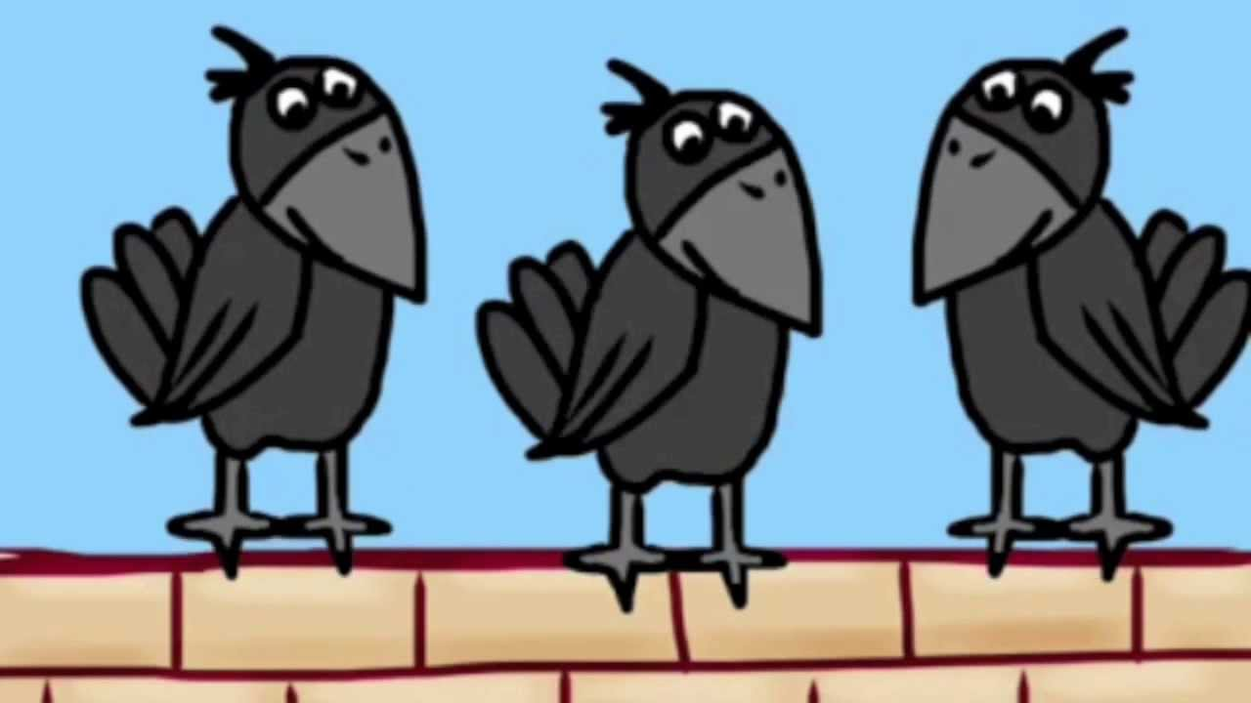
THREE CRAWS
Three craws sat upon a wa
Sat upon a wa, sat upon a wa aw aw aw
Three craws sat upon a wa
On a cold and frosty mornin.

The first craw fell an broke his jaw
Fell an broke his jaw
Fell an broke his jaw aw aw aw
The first craw fell an broke his jaw
On a cold and frosty morning.

The second craw was greetin for his maw
Greetin fur his maw
Greetin for his maw aw aw aw
The second craw was greetin for his maw
On a cold and frosty morning.
The third craw couldny flee at aa.
Couldny flee at aa
Couldny flee at aa aw aw aw
The third craw couldny flee at aa
On a cold and frosty morning.

The fourth craw wisnae there at aa
Wisnae there at aa
Wisnae there at aa, aw, aw, aw
The fourth craw wisnae there at aa
On a cold and frosty morning.

