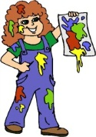  Craft | The children are enjoying free play in craft and a big supply of junk has been handed in so expect lots of models home! Some children have shown an interest in using letters of the alphabet in their pictures so we shall provide that for them.
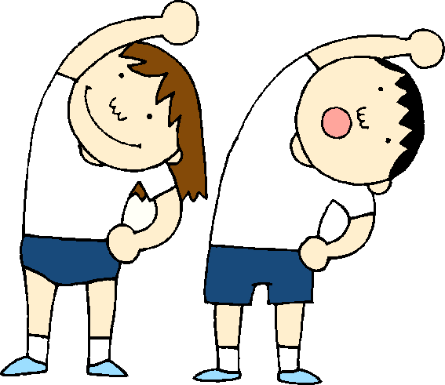  Health & Well Being | In the gym, the children are learning to follow instructions, use space effectively and understand the importance of exercise. They have shown a keen interest in their hearts and other body parts. We hope to develop this curiosity and awareness further in the nursery.
Construction | We have numbered our construction boxes so that the children can clearly sort the different materials in to the correct boxes. This helps at ‘tidy up’ time and develops their number recognition skills.
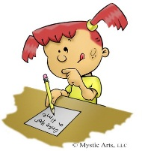  Literacy | The children have become engaged by ‘letter’ writing this week in the writing area and have been ‘posting’ them to their friends. We plan to post a few of their letters to them at home to demonstrate how the post works. If a letter is delivered to your home please take a photograph to share with us.
Sand | Some children are showing interest in writing their names. We will put out a sand tray with special ‘sand’ for them to trace their name in.
Games/puzzles | We have moved on from our ‘Pirate’ theme so the very popular ‘Pop Up Pirate’ game will be tidied away. However, we are planning to provide a healthy body theme (from the children’s interest in the gym) in our games and puzzles this week.

