**Exciting Changes in Nursery Schools**

**Recently nursery classes have been changing some of their approaches to learning, this is following advice from the Scottish Government. The guidelines from the Scottish Government have highlighted some good and exciting practice which we have been putting in to place gradually over this past session in Deans Nursery. Please speak to Mrs Lockhart if you want more details or read the following publication which makes the ideas come to life. Thank you for your understanding in this transition period.**

**Building the Ambition**National Practice Guidance on Early Learning and Childcare  
Children and Young People (Scotland) Act 2014  
[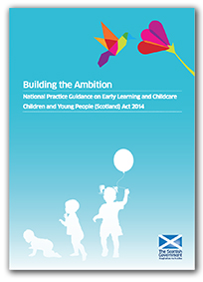](http://banchory-pri.aberdeenshire.sch.uk/wp-content/uploads/Building-the-Ambition.pdf)

[Building the Ambition - The Scottish Government](http://www.gov.scot/Resource/0045/00458455.pdf)

www.gov.scot/Resource/0045/00458455.pdf