Maths about Me!



**My**

**Birthday**



**Number of Teeth teeth**



**My House Number**



**Number of People in my Family**



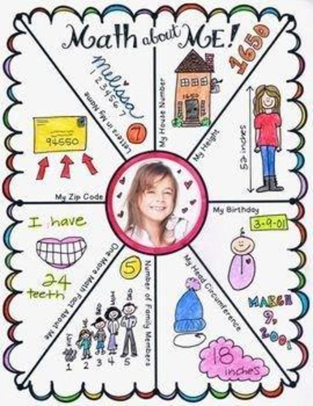

**Primary 1 homework-Maths Week Scotland 2020**

We will be completing various activities in school over the course of this week

to show that maths and numbers are all around us.

Many thanks

Mrs McKay and Miss Mackay