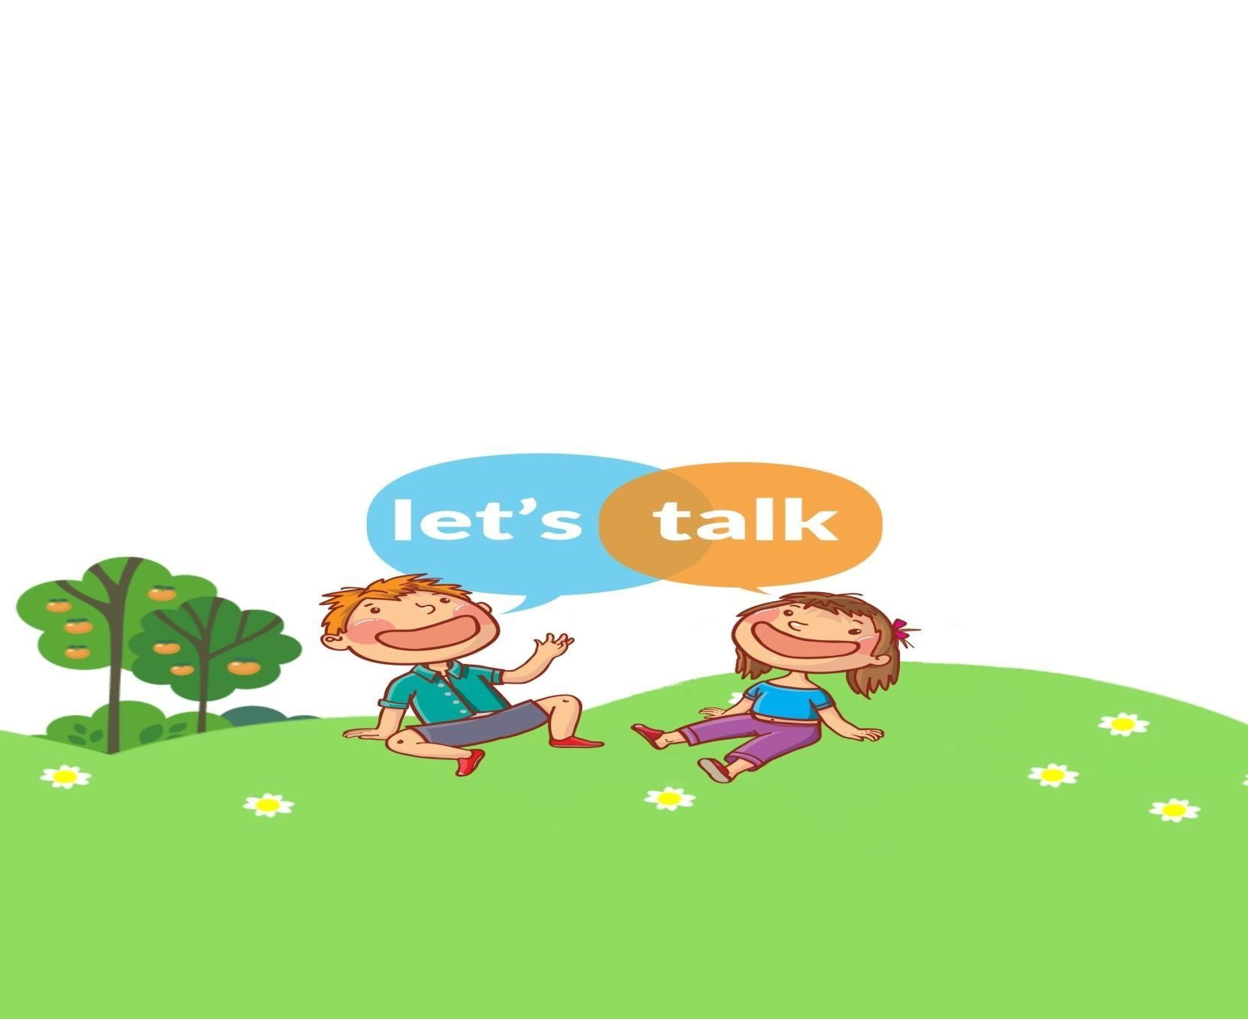
Call us to chat to a speech and language therapist about your concerns and get some practical advice on how you can help your child develop their language and talking!
LET’ S TALK

Speech and Language Therapy

Advice Phone Line

Do you have concerns or would like a little more

information about your child’s listening and talking?

Is your child under 4 years old?

Wednesday 12.30pm – 2.30pm
Thursday 3.30pm – 5.30pm
07866 219 181
www.lets-talk.scot.nhs.uk

