Phonics Grid – practising sounds learnt
I can blend to read words
I can segment to make/write words.

- Missing letters. Fill in the missing letters to make a word that matches the picture.

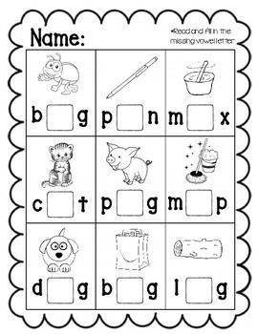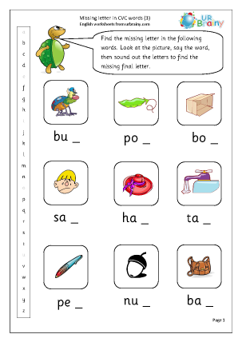

- Roll and read. You will need a die/dice. Roll it and read the first word. If you rolled one, you would read “bad”. If you rolled one again, you would read “sag”.

There are two roll and read sheets – one to practise “a” and one to practise “o” sounds in the middle.

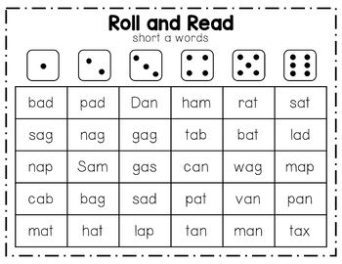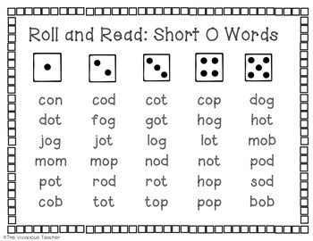
- Here are some games to practise phonics and reading words:
https://www.bbc.co.uk/bitesize/topics/zf2yf4j - for initial sounds
https://www.phonicsplay.co.uk/resources/phase/2/picnic-on-pluto - for reading words
- Write the word under the picture:

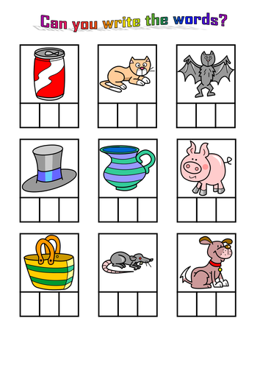
- Match the words and pictures:
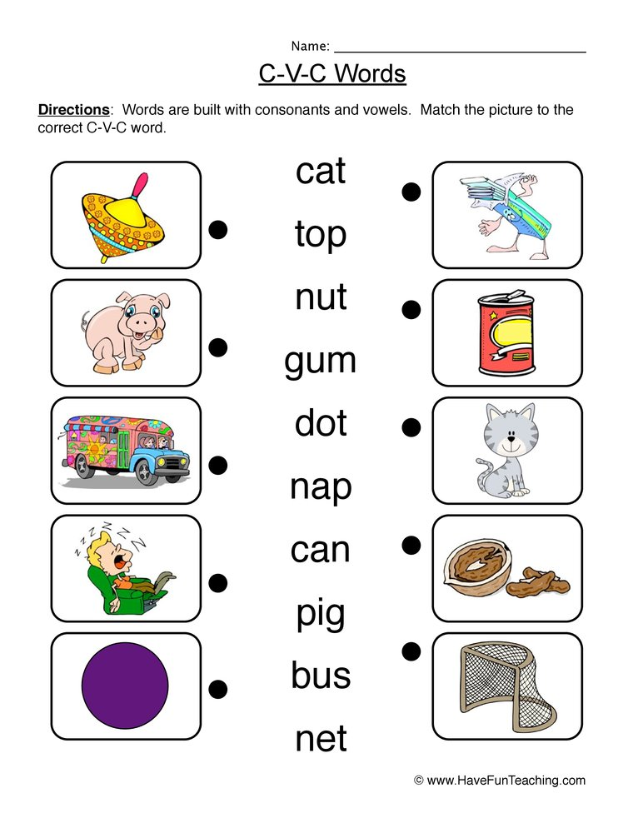

- Speed Read: See how many of these words you can read in a minute. Try again and see if you can read more. You can read them in any order:
dip | bit
end | man
cat | kit
lick | sip
mit | mug
lot | leg
peg | pot
not | dog
din | fan
sin | pack
bus | bin

