LO: To tell the time using the hour and minute hands.
Success Criteria:
2 – I can write what time is shown on the clock.
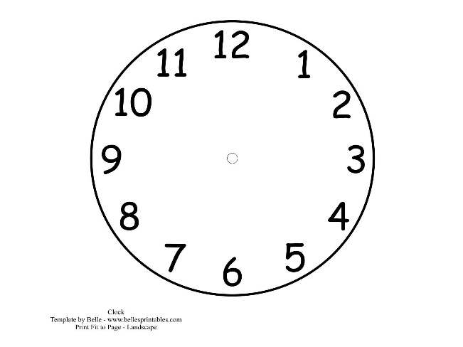

_______
_______
______

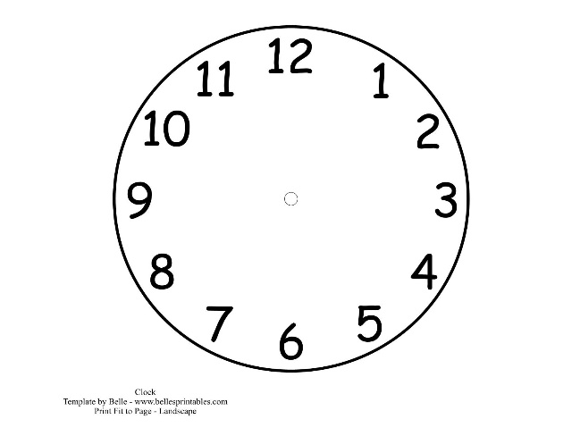

Challenge
LI- To solve problems with time
Ben runs to school. He leaves at 8 o’clock and it takes him 1 hour to get there.  What time does he arrive? | Lina goes to gymnastics at 5 o’clock. Her lesson takes an hour.  What time does her gymnastics lesson finish?
Jill cycles to the shop. She leaves at 12 o’clock. 2 hours later Jill is home. What time does Jill arrive home? | Frank went to his tennis lesson at 11 O’clock. His lesson is 1 hour long. What time did he finish?
Harry goes to the beach for the day with his family. He leaves at 11 o’clock. He is out for 3 hours. What time does he get home? | Jay came home from his tennis lesson at 4 o’clock. He was out for 2 hours. What time did he leave to go to his lesson?
Extension: Can you think of your own time word problem?
_________________________________________________________________________________
_________________________________________________________________________________
_________________________________________________________________________________

