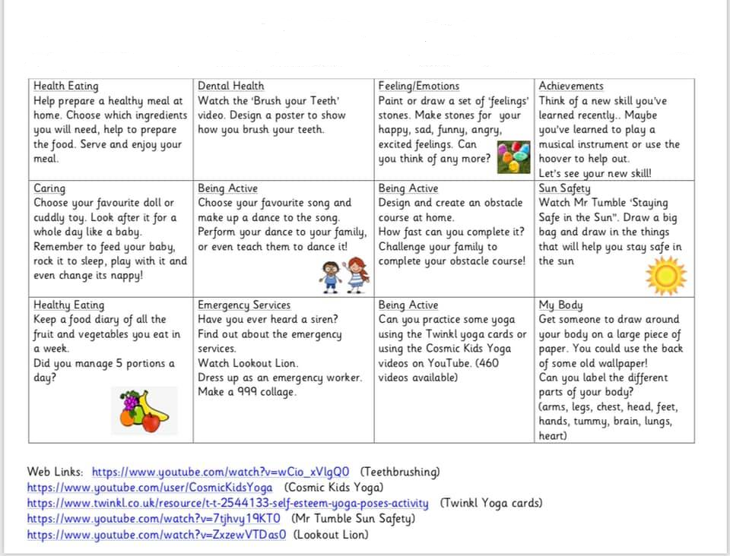

https://www.youtube.com/watch?v=synTxcnHyrA (Teethbrushing)
https://www.youtube.com/user/CosmicKidsYoga (Cosmic Kids Yoga)
https://www.youtube.com/watch?v=7tjhvy19KT0 (Mr Tumble Sun Safety)
https://www.youtube.com/watch?v=ZxzewVTDas0 (Lookout Lion)

The following activities could be used throughout the week to help the children keep active, build fitness and stamina but most of all we want them to have fun
https://www.thinglink.com/card/1324816909186629634?fbclid=IwAR0BCZwez3hi_MO8ALYXrUQddhj6YHgKoVdJdhW9mBhI-I3bmtjY5yJvxLg

