Finding a Quarter Lesson 1.
Children explore quarters for the first time. They will develop their understanding of equal parts and non-equal parts and relate this to a shape or object being split up into four equal parts. Children will use the words quarters and parts at this stage but will not use the fractional notation of 14
- How many parts does my whole have?
- Are my parts equal or not equal?
How many equal parts can we see/count?
- Can we make a quarter in a different way?
- Which shapes show equal parts?
- Which shapes show four equal parts? Which shapes show quarters?
Take two square pieces of paper, two circular pieces of paper and two rectangular pieces of paper.
Model folding one of each into four equal parts and the other into four non-equal parts.

- Which shapes show equal parts?
- Which do not?
How many equal parts can we see?
Can we fold any of the shapes in a different way and still get equal parts?
- Count the equal parts and then model counting them in quarters.
Colour a quarter of each shape.
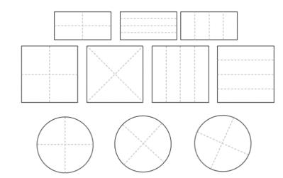

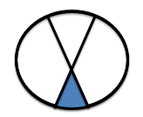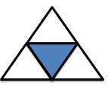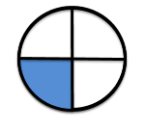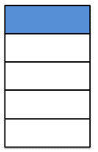
Tick the shapes that show quarters.

