Tuesday 26th May 2020
Daily Activities

Below you will find each curricular area Numeracy/Literacy/Across the curriculum. You can choose a couple of activities in each section to complete.

Numeracy

- Play times table tennis – select a times table and with another person, alternatively say each station of the table. If you make an error, start the times table again. Try and complete as many tables as you can.
- Go on a maths nature hunt outside. Can you find some natural objects that represent a particular number?
- Sumdog – 3/4 activities to complete
- Choose a challenge below
Mild
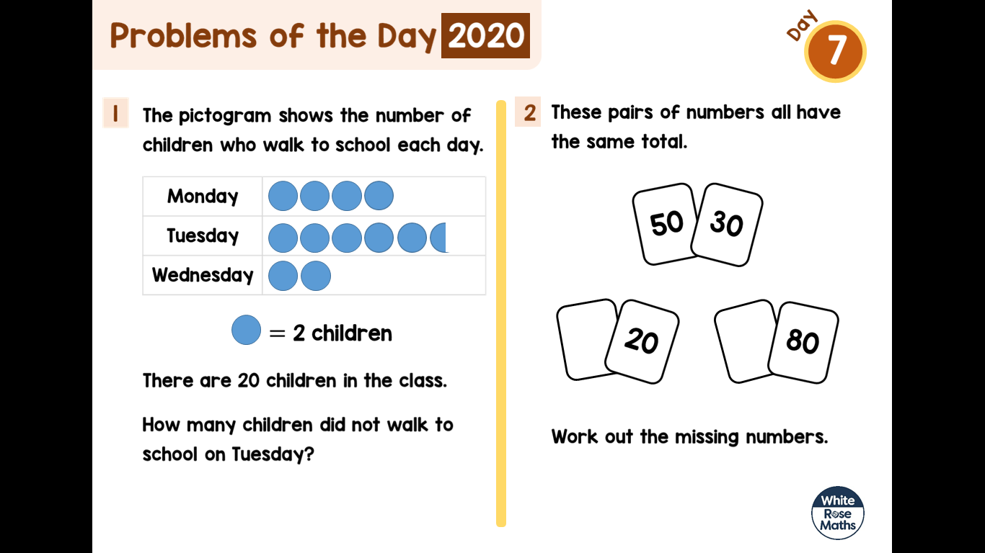
Hot
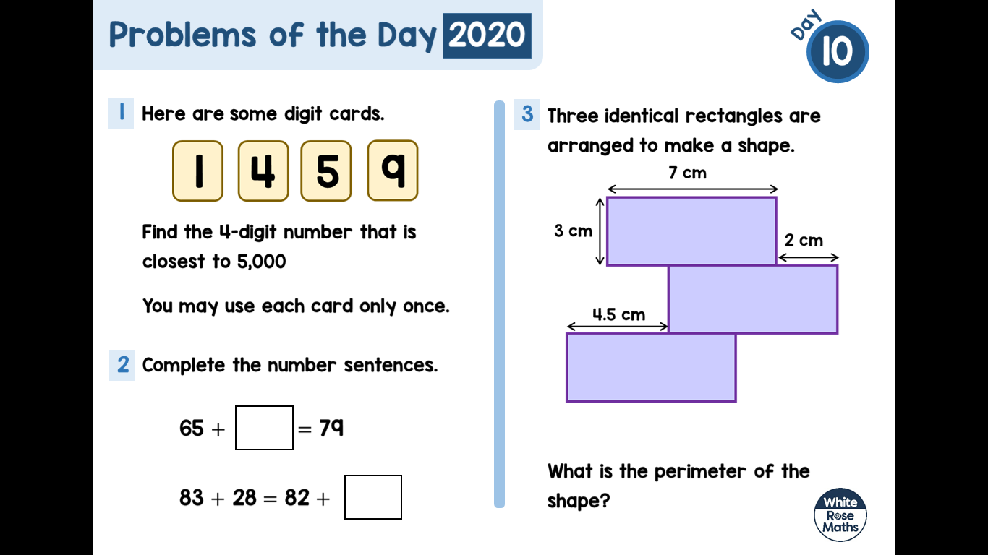
Literacy
- Using your spelling words, find a flower or tree in your garden or out on your walk – have a go at drawing it. Write each spelling word on one of the petals or leaves.
Positive Pineapples | Wonderful Watermelons | Keen Kiwifruits
sure  pure  cure  insure  injure  lure  assure | future  nature  creature  mixture  mature  picture  secure | adventure  sculpture  puncture  texture  mixture  measure  exposure

- IDL cloud – complete 3 lessons
- Can you find a stone? How many words can you think of that rhyme with the word ‘stone’? Write a list of all the words. Find another 3 objects in your garden or out on your walk and write a list of all the words that rhyme with the object.
- Write a story with the title….The King’s Lost Crown.
- Choose a non-fiction text to read and write down 3 facts you have learnt.
- Write 3 sentences using the word of the day.
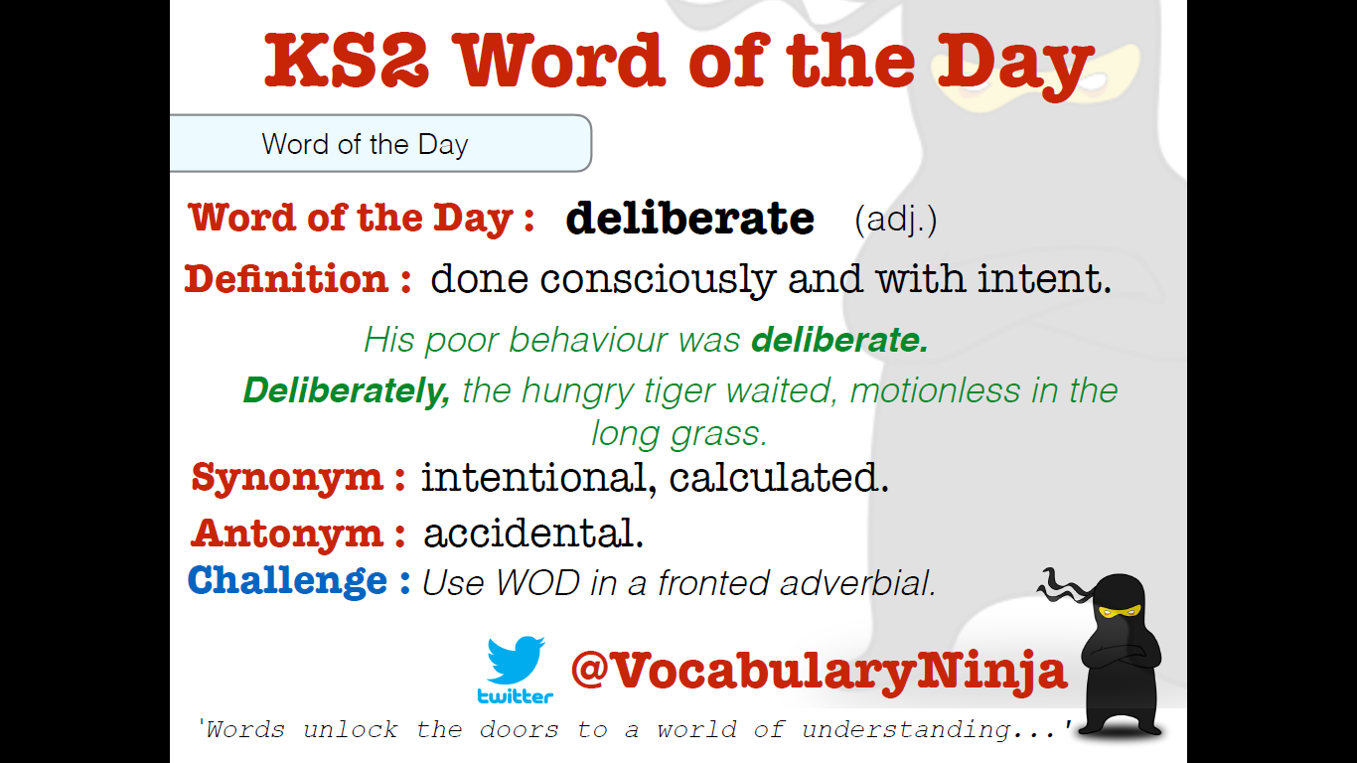

Across the Curriculum

Choose 1 activity below to complete this afternoon. (This is also uploaded onto files)

