Finding a Half Lesson 2

Children use their understanding of finding half of an object or shape and apply this to finding half of a small quantity.
It is important that children find the total amount and can then show how this number can be shared equally into two.

Mathematical Talk
- How can we find half of an amount?
How many groups do we need to share our beads between?
- How can you check that you have found half?
- How many equal parts should you have when you have split the objects in half?
Find half of each amount.

Find half of the amounts and complete the sentences.
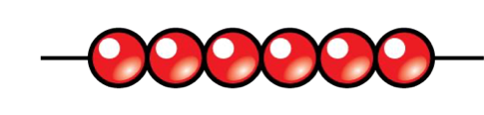
There are ____ beads. Half of ____ is ____.
There are ____ marbles. Half of ____ is ____.
There are ____ sheep. Half of ____ is ____ Find half of the sheep.
