Today’s Maths challenge!

Can you use tally marks to represent the quantity and total them up at the end?

From 5, can you skip count tally marks in 5s to help you calculate the total?

Can you collect the information to answer questions?

[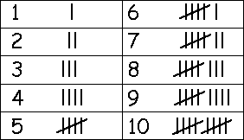](http://www.google.co.uk/url?sa=i&rct=j&q=tally+chart&source=images&cd=&cad=rja&uact=8&docid=pqk-ErwMihKvpM&tbnid=yasNoGHgmqU-TM:&ved=0CAUQjRw&url=http://www.mathatube.com/glo-tally-marks.html&ei=zG46U9_yIdOThge67oDoBg&bvm=bv.63934634,d.ZG4&psig=AFQjCNGJ21bh09jHftSRpQnD50CIKhptZQ&ust=1396424661543157)

Don’t forget to use a diagonal line when you reach a multiple of 5!

Example

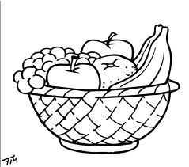**Favourite Fruit**

Shoppers in the supermarket were asked in a survey which was their favourite fruit. Here is a list of their responses.

|  |  |  |
| --- | --- | --- |
| FRUIT | TALLY | TOTAL |
| Apple | //// // | 7 |
| Banana | //// | 5 |
| Grapes | //// /// | 8 |
| Orange | /// | 3 |

1. Which fruit was the most popular? Grapes
2. Which fruit was the least popular? Orange
3. How many people were surveyed all together? 23 people
4. Order the fruits from most popular to least popular?
5. Grapes
6. Apples
7. Banana
8. Orange

 **Task - Favourite Country to Visit**

**Carry out a survey and ask or telephone your family and friends to find out which country they would most like to visit.**

**Draw and complete this Tally Chart in your jotter and use the information to answer the questions below (you can change the countries if you wish).**

|  |  |  |
| --- | --- | --- |
| Country | TALLY | TOTAL |
| SPAIN (With images) | Spain flag, Spanish flagsSpain |  |  |
| France Flag at 14.9€France |  |  |
| Henbrandt Italy National Flag 5ft x 3ft: Amazon.co.uk: Toys & GamesItaly |  |  |
| Flag of Greece - WikipediaGreece |  |  |

1. Which country was the most popular to visit?
2. Which country was the least popular to visit?
3. How many people were surveyed all together?
4. Order the countries from most popular to least popular?