Finding a Half Part 2

Mrs McKay and Miss Mackay are trying to split a rectangle in half. Miss Mackay thinks she has worked out the only answer.



Mrs McKay says, “That’s a good try but I think there are more ways to half a triangle.”

Can you help Mrs McKay to find more ways to half the triangle?

Sort the shapes into the table.

|  |  |
| --- | --- |
| Shapes that are split in half | Shapes that are not split in half |
|  |  |

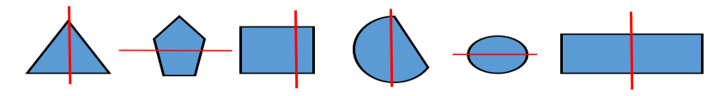

Can you add any more shapes to the table?