

Finding a Half

Children explore finding a half for the first time using shapes and sets of objects. They will use the vocabulary ‘half’ and ‘whole’. Children will not at this stage use the fractional notation of 1 2.

It is important that they know that a half means ‘one of two equal parts’ and are able to count them.

Mathematical Talk

How many parts have I split my object into?

How can you show a half of something?  
How do you know if a shape is split into halves?

How many halves make a whole?

Can we count them?  
How do you know if an object or shape has not been split in half?  
Is there more than one way to show half of a shape or object?

Is this the same for all shapes?

Show the children real life objects and how they can be cut in half.  
How can we cut these objects in half?

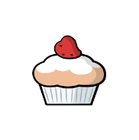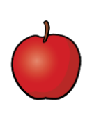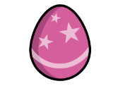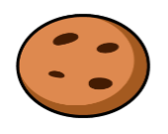

Can any of the objects be cut in half in more than one way? Which circles have been split into equal halves?

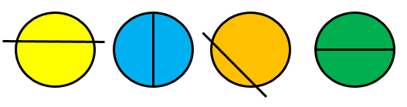

Match the halves to make 5 complete shapes.

