**Money Task 3**

Giving Change

**LI: To work out change**

**SC – Give change from 10p/20p/50p**

* **Subtract by counting backwards**
* **Use knowledge of friends of 10**

**Draw each of the items and price tags in your jotter and use your subtraction knowledge to work out the change.**

**Example:**

15p

**j0297925**

**Paying with 20p**

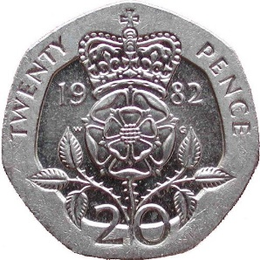

How much

change?

5p

**20-15=5**

**You can use the counting backwards strategy.**

The biggest number is always first in a take away sum.  Put it in your head. Now count backwards tracking the number on your fingers.

**You can use your friends of 10.**

**You can use items to help you with the subtraction, for example buttons or pieces of Lego.**

There are Mild, Hot and Spicy ones to choose from.  If you complete a set and find it easy try the next one!