Outdoor Classroom Day 2020
Mindfulness  Cloud Gazing  Is it a bird?  Is it a plane?  No, it’s a giant marshmallow monster eating a bowlful of squirty cream!  Lie down and look from a window or outdoors and enjoy cloud land.  https://www.ltl.org.uk/resources/cloud-gazing/ | Maths  Sparks and Feathers Open for Business!  This resource has a price list for natural materials so, next time you’re out make some purchases from nature’s shop and work out how much you’ve spent – maybe you have a budget! Indoors, create a new price list, grab a bag and role play shop with any goods at all!  Resources 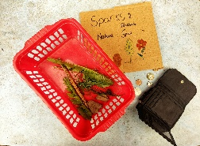 | STEM  Build a nest strong enough to hold a clutch of eggs and withstand the wind. Slender, bendy twigs are best. Weave them together to make a basic nest shape. Use dried grass and fallen leaves to fill in any gaps. When you’ve finished, test it out by putting some small stones or tree cones inside. Can your nest take the weight without falling apart?  The sheet in the resource files
STEM  In the garden lift up stones and logs and see if you can spot creatures living underneath.  Can you spot any creatures with no legs?  Worms or slugs?  Draw a diagram of what you find! | PE  Using any materials, create an obstacle course. This could involve running, crawling, skipping, star jumps, hopping on one leg, balancing etc. You could even illustrate instructions!  Challenge: Time how long it takes you to complete your obstacle course. Can you improve your time?  Calculate how many times would you complete the course in 10 minutes / 20 mins? Can you work this out mathematically? | Art  Paint/draw/ illustrate a landscape of your outdoor space or somewhere on a walk. Can you use different colours, techniques, textures, materials, patterns to add detail?  Look carefully at natures’ palette. The different greens and browns, and sometimes vivid flower colours.  Challenge: Think of some descriptive language. Can you use the senses? Creatively write about your landscape, e.g. description, poem, story.
STEM  Make a teddy zip wire to find the quickest way for teddies to descend from different heights:  https://www.science-sparks.com/teddy-zip-wire/  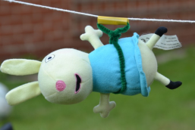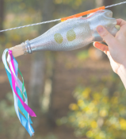  Challenge: Can you time the descent and find the fastest combination of zipline, harness and incline of the wire?  How can you make the teddy go quicker or slower? Think about materials and what creates more friction. | STEM  FIT Count stands for ‘Flying Insect Timed Count’, and is a recognised UK survey. Why not join in! Sit and watch the flowers in your garden for exactly 10 minutes and record them on a tally chart. These could be any flowers in your garden – dandelions, daisies, clover, lavender etc.  What was the most common flying insect to visit your flowers? What does the information you have collected tell you? Did you see any other interesting insects?  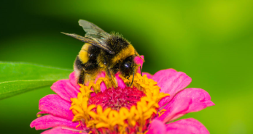  Challenge: What do you think attracts particular insects to your garden? | Literacy  Search all around your garden, can you find something different that represents each of the words listed below?  habitat petal  seed  metal rock  never alive plastic wood  waterproof smooth  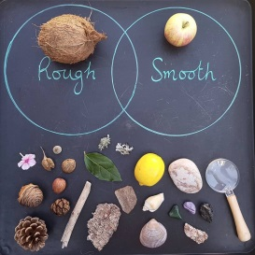  Challenge: Draw a Venn diagram to show 2 characteristics and their links.

