Maths Challenge
Money
Set up your own shop and write prices for each item.
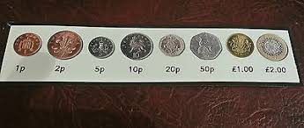
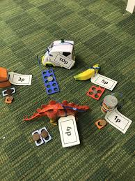

LI- To recognise and order coins from the least value to the most

Can you match the correct coin/s to the value of your items in your shop?
Can you order your items from the least value to the most?
Mild- Items value to up 10p.
Spicy- Items value up to 50p.
Hot- Items value up to £1 and beyond.

You can draw and cut out your own coins. Remember to draw the correct shape, colour and write the value on each coin.

