Tuesday 19th May 2020
Daily Activities

Celebrity classes – on files

Below you will find each curricular area Numeracy/Literacy/Across the curriculum. You can choose no more than two of the activities in each section to complete.

Numeracy

- BBC Bitesize – simplifying fractions
https://www.bbc.co.uk/bitesize/tags/z63tt39/year-4-lessons/1
- Be a Nature Spotter – start a nature survey. Jot down how many different birds, flowers or insects you can spot outside. First, record your results in a tally chart. Using your results create a bar graph.
- Choose a problem of the day below

Mild
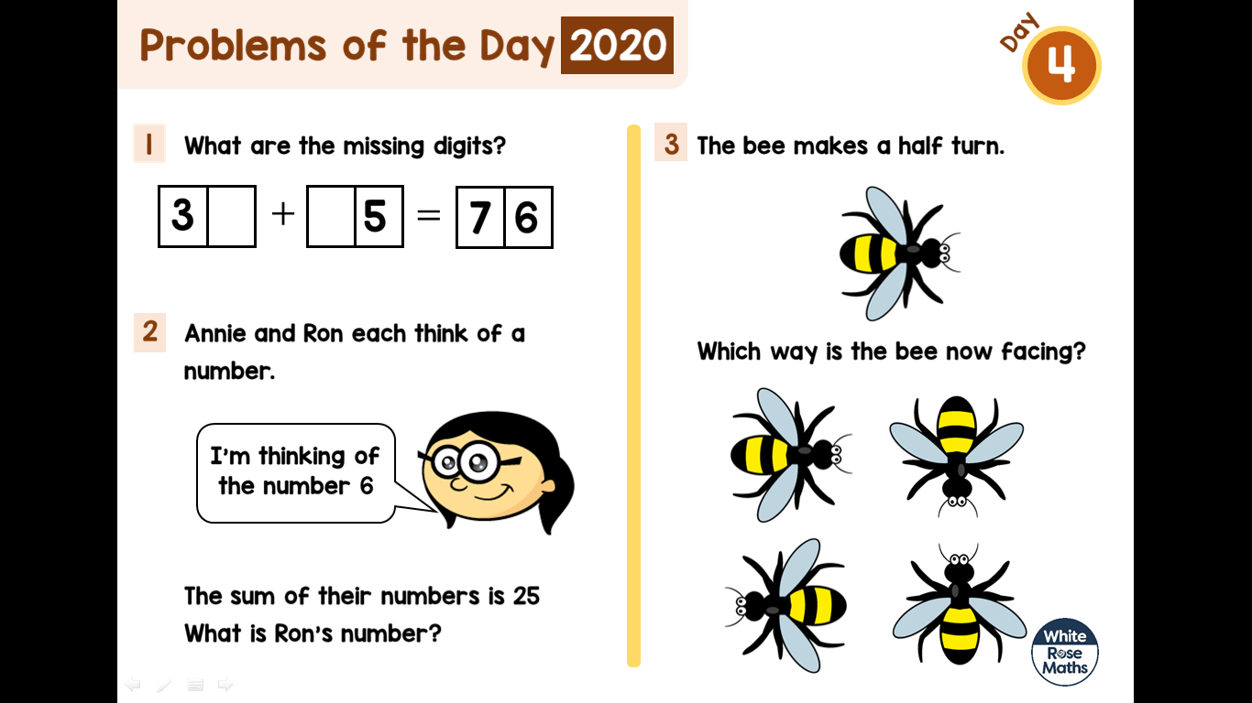

Hot
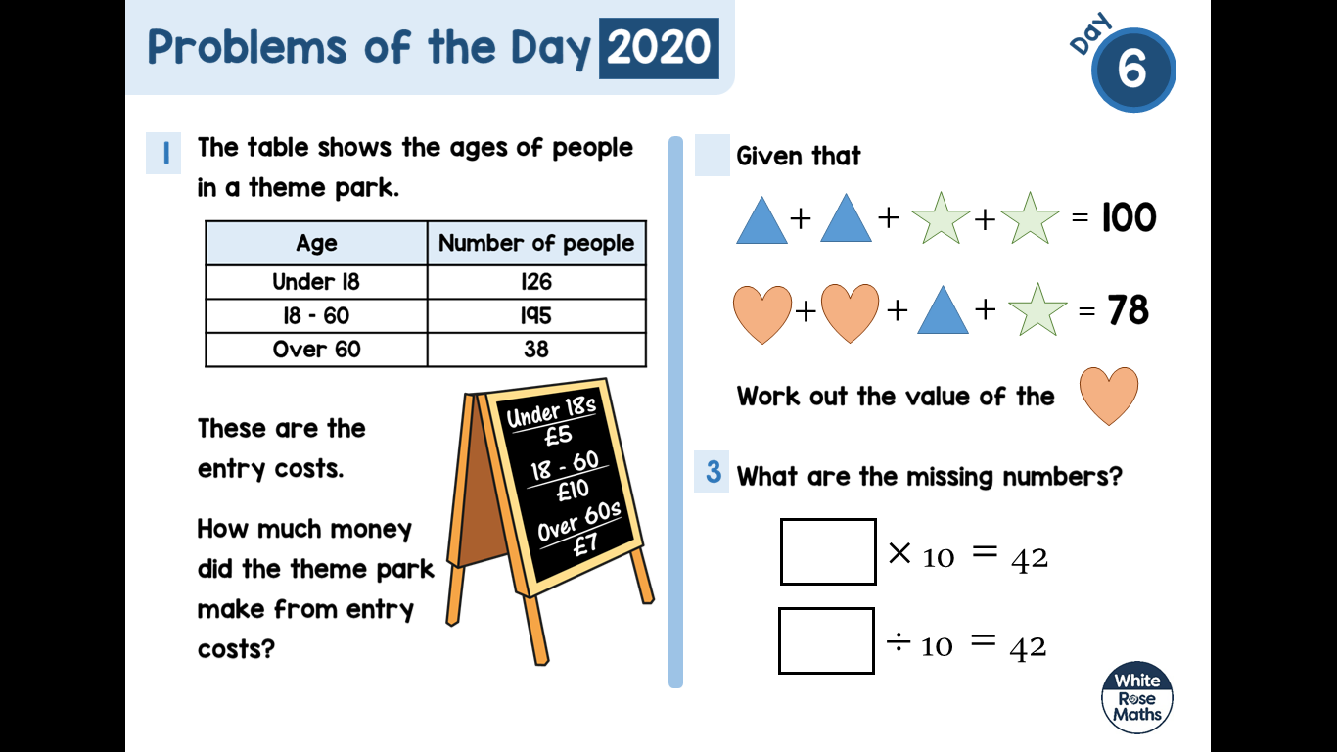

Literacy

- BBC Bitesize – formal and informal language
https://www.bbc.co.uk/bitesize/tags/z63tt39/year-4-lessons/1
- 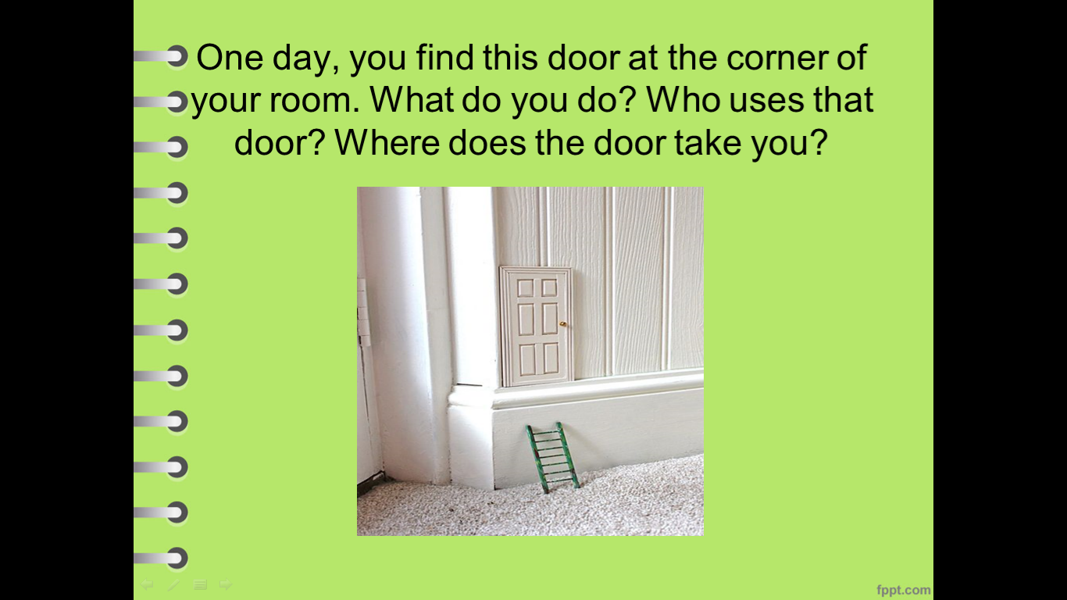
- Make a story sack – choose your favourite book and collect some items in a bag that have something to do with the book. Can someone else guess the book based on the items you have collected?
- Write 3 sentences using the word of the day below
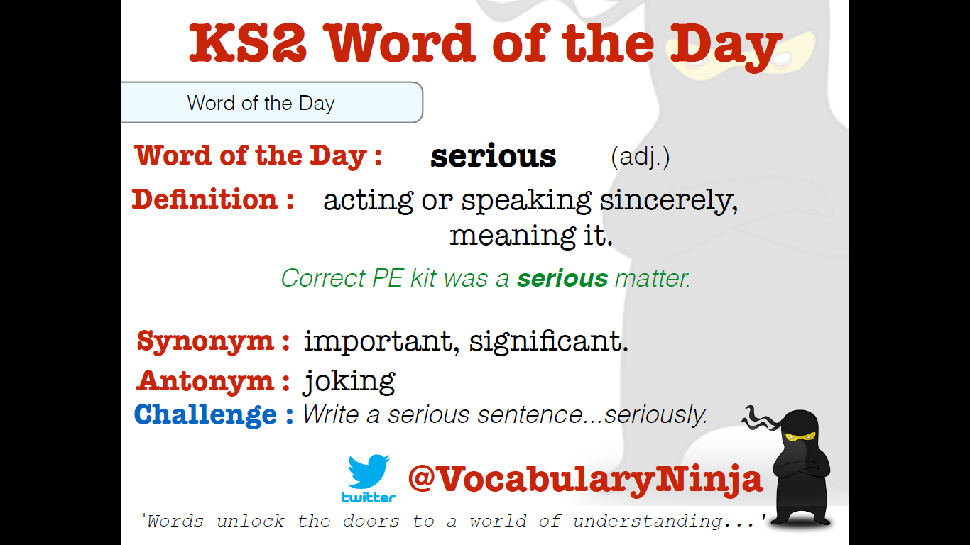
Across the Curriculum

Choose 1 activity below to complete this afternoon. (This is also uploaded onto files)

