Maths challenge

L.I. To identify the properties of 3D shapes.

Can you identify the properties of 3D shapes that you found on your shape hunt yesterday? Add a column for the vertices, edges and faces of each shape!

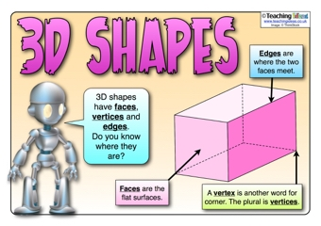

|  |  |  |  |
| --- | --- | --- | --- |
| Name of 3D shape | Example from my house (draw) | Vertices | Faces |
| Cylinder | C:\Users\jennifer.hall\AppData\Local\Microsoft\Windows\INetCache\IE\HXGRCML5\Soda[1].jpg | 0 | 2 |