Help! The magic shop is running out of some of our most popular potions! Using these ingredients, can you make us some more?

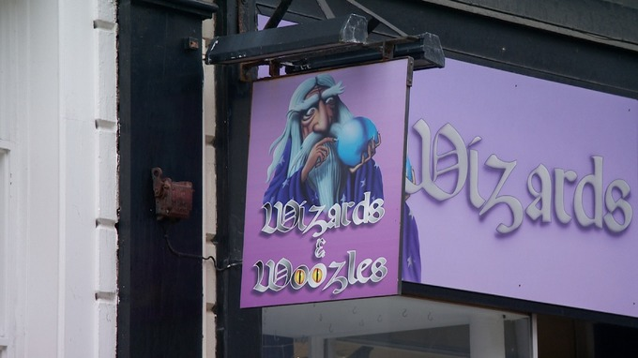

Dragons cough syrup

Ingredients

* 100ml lagoon water
* 200ml dragon snot
* 300ml unicorn tears
* 200ml troll blood
* 100ml liquid sunshine

Instructions

1. Add each ingredient one by one. Pour each slowly.

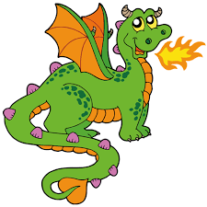

Unicorn shampoo

Ingredients

* 100ml unicorn tears
* 400ml liquid sunshine
* 100ml dragon snot
* 200ml troll blood
* 300ml lagoon water

Instructions

1. Add each ingredient one by one. Pour the liquid sunshine quickly and all the others slowly.

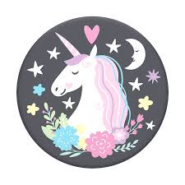

Ogre Shrinking potion

Ingredients

* 300ml dragon snot
* 400ml troll blood
* 200ml liquid sunshine
* 200ml unicorn tears
* 100ml lagoon water

Instructions

1. Add each ingredient one by one. Pour them in carefully, moving your hands over the top in circles.

2. Remember to say the magic words ‘Shrinko-shrinko’.

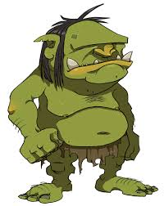

Giants toothpaste

Ingredients

* 100ml dragon snot
* 300ml lagoon water
* 200ml unicorn tears
* 300ml trolls blood
* 100ml liquid sunshine

Instructions

1. Add each ingredient one by one. Pour them slowly, whilst moving your hands in a circle.

2. Whisper ‘wait giant, let it brew’ over and over whilst mixing.

3. Hiccup and turn around three times when your potion is finished.

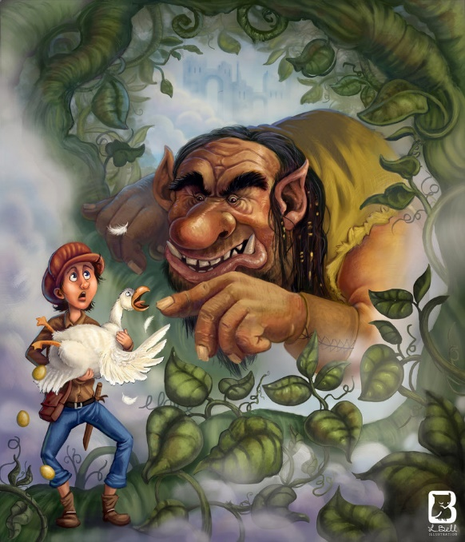

Labels for bottles/containers

|  |  |
| --- | --- |
| **lagoon water** | **dragon snot** |
| **unicorn tears** | **troll**  **blood** |
| **liquid**  **sunshine** |  |